



**THE UNIVERSITY OF JORDAN**

**KING ABDULLAH II SCHOOL OF INFORMATION TECHONLOGY**

**Graduation Project**

**ILM-Verse**

**Supervised by:**

**Dr.** **Moh'd Belal Al-Zoubi Dr.** **Esra Alzaghoul**



**Students:**

|  |  |
| --- | --- |
| **Name** | **ID** |
| **Mohamad Ayman Abudraiea** | **0219537** |
| **Anas Read Ghnaim** | **0211765** |
| **Abdallah Mahmoud Hamad** | **0214479** |
| **Karam Emad Yacoub** | **0214684** |

# Abstract

The ILM-Verse project aims to modernize the traditional learning process at Thinking Flares School (TFS) through an innovative e-learning platform tailored to students, parents, teachers, and administrators. This platform digitizes key educational and administrative processes, creating a user-friendly environment for personalized learning, enhanced communication, and efficient management.

The system addresses existing challenges in educational platforms by integrating interactive tools for assignments, quizzes, and progress tracking while involving parents through detailed reports and direct communication channels. Additionally, it incorporates marketing features to promote school achievements and events.

By bridging the gap between traditional and digital learning, the ILM-Verse platform enhances educational quality and collaboration, and supports the evolving needs of the school community.

# Table of Contents

Abstract 2

Table of Contents 3

1.0 Introduction 10

1.1 Motivation 10

1.2 Statement 10

1.3 Aim and Objectives 11

1.4 Scope 13

1.5 Software and Hardware Requirements 14

1.6 Expected output 14

1.7 Limitations 15

1.8 Project Schedule 17

1.9 Report Outline: 20

2.0 Related Existing Systems 21

2.1 Overview about existing systems: 21

2.2 Problems of existing systems: 21

2.3 Proposed solutions 22

3.0 SYSTEM REQUIREMENTS ENGINEERING AND ANALYSIS 23

3.1 Feasibility Study 23

3.1.1 Technical Feasibility 23

3.1.2 Operational Feasibility 24

3.1.3 Legal Feasibility 25

3.1.4 Economical Feasibility 26

3.2 Requirements gathering techniques 29

3.2.1 Interviews 29

3.2.2 Questionnaires 31

3.3 The targeted users (Stakeholders) 36

3.4 functional requirements definition and specification 38

3.5 Non-functional requirements 46

3.6 Usability and user experience goals. 47

4.0 SYSTEM DESIGN 48

4.1 Architecture Design 48

4.2 Entity Relationship Diagram (ERD) 49

4.3 UML Use Case Diagram 49

4.4 UML Sequence Diagram 54

4.5 Database Design 120

List of figures

Figure 1 Pert diagram 20

Figure 2 Questionnaires 1 31

Figure 3 Questionnaires 2 31

Figure 4 Questionnaires 3 32

Figure 5 Questionnaires 4 32

Figure 6 Questionnaires 5 33

Figure 7 Questionnaires 6 33

Figure 8 Questionnaires 7 34

Figure 9 Questionnaires 8 34

Figure 10 Questionnaires 9 35

Figure 11 Questionnaires 10 35

Figure 12 Architecture Diagram 48

Figure 13 ERD 49

Figure 14 USE CASE 1 STAFF INITIAL FUNCTIONALITY 49

Figure 15 USE CASE 2 Learning Management Tools 50

Figure 16 USE CASE 3 Common Functionality 51

Figure 17 USE CASE 4 Student-Parent Access System 52

Figure 18 USE CASE 5 Messaging System 52

Figure 19 USE CASE 6 Posts System 53

Figure 20 Sequence Diagram 1 Login-Staff 55

Figure 21 Sequence Diagram 2 Add Teacher 57

Figure 22 Sequence Diagram 3 Student 58

Figure 23 Sequence Diagram 4 Add Parent 60

Figure 24 Sequence Diagram 5 Delete Teacher 61

Figure 25 Sequence Diagram 6 Delete Teacher 63

Figure 26 Sequence Diagram 7 Delete Teacher 64

Figure 27 Sequence Diagram 8 Change User Password 66

Figure 28 Sequence Diagram 9 Add Secretary 68

Figure 29 Sequence Diagram 10 Delete Secretary 70

Figure 30 Sequence Diagram 11 View Course 71

Figure 31 Sequence Diagram 12 Add Assignment 73

Figure 32 Sequence Diagram 13 Add File 74

Figure 33 Sequence Diagram 14 Add Lectures 76

Figure 34 Sequence Diagram 15 Add Quiz 77

Figure 35 Sequence Diagram 16 Delete Content 79

Figure 36 Sequence Diagram 17 Search Student 80

Figure 37 Sequence Diagram 18 Show Students 82

Figure 38 Sequence Diagram 19 Add Marks 85

Figure 39 Sequence Diagram 20 Generate Report 88

Figure 40 Sequence Diagram 21 Edit Marks 90

Figure 41 Sequence Diagram 22 Log-out 91

Figure 42 Sequence Diagram 23 Forgot Password 93

Figure 43 Sequence Diagram 24 Student-Parent Log-in 94

Figure 44 Sequence Diagram 25 View Student Courses 96

Figure 45 Sequence Diagram 26 Upload File 97

Figure 46 Sequence Diagram 27 Delete File 99

Figure 47 Sequence Diagram 28 Download File 100

Figure 48 Sequence Diagram 29 View Grades 102

Figure 49 Sequence Diagram 30 View Reports 103

Figure 50 Sequence Diagram 31 Show Absences 104

Figure 51 Sequence Diagram 32 Search By Name 107

Figure 52 Sequence Diagram 33 Send Message 109

Figure 53 Sequence Diagram 34 Receive Message 111

Figure 54 Sequence Diagram 35 send Announcement 114

Figure 55 Sequence Diagram 36 Add Post 116

Figure 56 Sequence Diagram 37 Delete Post 117

Figure 57 Sequence Diagram 38 Edit Post 119

Figure 58 EERD 120

Figure 59 JSON Format 1 Assignment Post 121

Figure 60 JSON Format 2 Post 121

Figure 61 JSON Format 3 FilePost 122

Figure 62 JSON Format 4 SubmissionFile 122

Figure 63 JSON Format 5 Quiz 123

Figure 64 JSON Format 6 Message 123

Figure 65 JSON Format 7 Lecture Post 124

List of tables

Table 1 Abbreviations 9

Table 2 Software And Hardware Requierments 14

Table 3 Project Schedule 17

Table 4 Technology Stack 23

Table 5 Personnel development costs 26

Table 6 Hardware and Software Development costs 26

Table 7 Operating costs 26

Table 8 Fixed costs 27

Table 9 Constant costs 27

Table 10 Tangible Benefits 27

Table 11 Payback Analysis 28

Table 12 Functional Requirements definition and specification 46

Table 13 Non-functional requirements 46

Table 14 Log-in Staff Description 55

Table 15 Add Teacher Description 56

Table 16 Add Student Description 58

Table 17 Add Parent Description 59

Table 18 Delete Teacher Description 61

Table 19 Delete Parent Description 62

Table 20 Delete Student Description 64

Table 21 Change User Password Description 65

Table 22 Add Secretary Description 67

Table 23 Delete Secretary Description 69

Table 24 View Course Description 71

Table 25 Add Assignment Description 72

Table 26 Add Files Description 74

Table 27 Add Lectures Description 75

Table 28 Add Quiz Description 77

Table 29 Delete Content Description 79

Table 30 Search Students Description 80

Table 31 Show Students Description 82

Table 32 Add Marks Description 84

Table 33 Generate Report Description 87

Table 34 Edit Marks Description 90

Table 35 Log-out Description 91

Table 36 Forgot Password Description 93

Table 37 Student And Parent Log-in Description 94

Table 38 View Student Courses 95

Table 39 Upload File 97

Table 40 Delete File Description 98

Table 41 Download File Description 100

Table 42 View Grades Description 101

Table 43 View Reports Description 103

Table 44 Show Absences Description 104

Table 45 Search By Name 106

Table 46 Send Message Description 109

Table 47 Receive Message Description 111

Table 48 Send Announcement Description 114

Table 49 Add Post Description 115

Table 50 Delete Post Description 117

Table 51 Edit Post Description 118

List of Abbreviations

|  |  |
| --- | --- |
| Abbreviation | Full Name |
| **TFS** | Thinking Flares School |
| **JD** | Jordanian Dinar |
| **JIS** | Jordanian International Schools |
| **HTML** | Hyper Text Markup Language |
| **CSS** | Cascading Style Sheet |
| **JS** | Java Script |
| **SHA** | Secure Hash Algorithm |
| **HTTPS** | Hyper Text Transfer Protocol Secure |
| **UI** | User Interface |
| **UX** | User Experience |
| **RAM** | Random Access Memory |
| **ROI** | Return on Investment |
| **OOAD** | Object Oriented Analysis And Design |
| **ERD** | Entity Relationship Diagram |
| **JSON** | Java Script Object Notation |
| **DBMS** | Database Management System |
| **RDB** | Relational Database |
| **NRDB** | Non-Relation Database |
| **EERD** | Enhanced Entity Relationship Diagram |

Table Abbreviations

# Introduction

## 1.1 Motivation

The main motivation of the ILM-Verse project is to support the traditional learning process in Thinking Flares School (TFS) by transforming and digitizing various learning aspects into an E-Learning Website that supports all participants in the educational process, including teachers, students, parents, and administrators. The system aims to manage both educational and non-educational outcomes, provide a more personalized and convenient learning environment, facilitate easier and more efficient communication, and save time and effort for all stakeholders.

## 1.2 Statement

The objective of this project is to design, develop, and implement a comprehensive and dynamic E-Learning System that enhances the educational experience for all stakeholders. The system will digitize key learning processes, support remote and blended learning environments, and provide tools for managing educational content (assignments, assessments, and feedback). Additionally, it will include features for effective communication among teachers, students, parents, and administrators, ensuring transparency and collaboration.Also, Parents will also be able to monitor their children's progress and performance, enabling them to stay actively involved in the educational proccess. The system aims to be user-friendly, scalable, and adaptable to the evolving needs of the school, that will bridge the gap between traditional and modern educational techniques while saving time and effort.

## 1.3 Aim and Objectives

**Project Aim:**

The main aim of this project is to develop E-Learning systems that improve the educational process in all aspects. Also, Our Aim have 4 main goals:

1. **Educational Goals:** by digitizing a lot of physical processes into technical aspects inside the website such as (Assignments, Recorded Lectures, quizzes, work sheets .... etc.). which will save a lot of time and effort for the teachers and gives more space for the students and their parents to have the maximum benefit of learning aspects
2. **Monitoring Goals**: by involving the parents directly in the educational processes throw Enabling them to monitor their children's marks, progress and performance by weekly and daily reports. As well as that they will have direct communication between the teachers and the administrators.
3. **Marketing Goals**: by adding sections inside the website that reflects the environment of the School, Events and any activity that supports the marketing side
4. **Administrative Goals**: by giving a large area for administrators for monitoring and communicating with the teachers, students and parents based on hierarchy of roles for different administrators.

**Project Objectives:**

1. **User-Friendly Interface:**

Ensure that the system is intuitive and easy to navigate for all users, including students, teachers, parents, and administrators.

Ensure the system works smoothly across all platforms and devices, including laptops, tablets, and smartphones.

1. **Integrated Back-End System:**

Design a robust, scalable, and secure database to store user information, academic records, and other data.

Ensure seamless integration between the front-end interface and back-end systems for smooth operation.

Include an APIs to enable integration with third-party educational tools and platforms.

1. **Provide Learning Management Tools:**

Provide tools for creating, organizing, and delivering educational content, including multimedia resources, quizzes, and worksheets.

Implement features for automated grading and feedback to save time for teachers.

1. **The ability of Monitoring and Tracking Progress:**

Develop dashboards for parents that track students' academic progress, attendance and performance feedback.

Develop automated generation of weekly and monthly progress reports for parents and administrators.

1. **Enhance Scalability and Adaptability:**

Design the system to support an increasing number of users and data as the school grows.

Ensure that the system can adapt to changing educational needs and technological advancements.

1. **Include Marketing Features:**

Add sections for showing school events, achievements, and non-educational activities to attract more customers.

Include a gallery section to highlight the school facilities and environment.

1. **Ensure Security and Privacy:**

Implement user authentication and role-based access control to ensure data security.

Encrypt sensitive information to achieve user privacy.

1. **Communication Channels:**

Develop messaging systems for communication among stakeholders.

Provide notifications and alerts for important updates, deadlines, and announcements.

## 1.4 Scope

The ILM-Verse project aims to develop a secure, interactive, and user-friendly e-learning platform tailored for Thinking Flares School (TFS). The platform will includes:

1. **Educational Features**: Provide tools for managing assignments, quizzes, recorded lectures, and worksheets, ensuring consistency in teaching styles
2. **Parental Involvement**: Offer detailed progress reports on marks, attendance, and behavior, with direct communication channels for parents and teachers.
3. **Unified Access**: Consolidate all essential educational data into one platform for easy access and navigation.
4. **Marketing Features**: Showcase school achievements, events, and facilities to attract and retain students.
5. **Legal Compliance**: Ensure that the platform achieves the Jordanian Ministry of Education regulations, secure data with encryption, and use a compliant domain name (.edu.jo).
6. **Accessibility**: Support cross-platform access on web browsers bearing in mind that Arabic Language is just accepted.

## 1.5 Software and Hardware Requirements

|  |  |  |  |  |
| --- | --- | --- | --- | --- |
| # | Resource | Quantity | Unit Price (JD) | Total Price |
| HD1 | Laptops with minimum 8GB RAM | 4 | 500 | 2000 |
| HD2 | High-speed internet connection | 1(monthly) | 50 | 50 |
| HD3 | Server | 1(annual) | 1500 | 1500 |
| SW4 | VS Code | 4(free) | 0 | 0 |
| SW5 | Node.js | 4(free) | 0 | 0 |
| SW6 | PostgreSQL | 4(free) | 0 | 0 |
| SW7 | Git and GitHub | 1(free) | 0 | 0 |
| SW8 | Figma | 1(monthly) | 25 | 25 |
| SW9 | Postman | 1(free) | 0 | 0 |
| SW10 | Host name | 1 | 25 | 25 |
| SW11 | Google Forms | 1(free) | 0 | 0 |
| Total |  |  |  | 3600 |

Table Software And Hardware Requierments

## 1.6 Expected output

The successful completion of this project is expected to deliver the following outputs:

1. **Comprehensive E-Learning System**:

An easy-to-use e-learning system designed for TFS simplifies learning, teaching, and progress tracking for everyone involved in the educational process. that must be cross- platform.

1. **Secure and Scalable Platform:**

A secure system with encrypted data and role-based access control, designed to handle an increasing number of users and data.

1. **Digitized Learning Tools:**

Features for creating and managing assignments, quizzes, recorded lectures, and other educational resources.

1. **Progress Tracking Dashboards:**

Interactive dashboards for students, parents, and administrators to monitor academic performance, attendance, and progress.

1. **Communication System:**

Integrated messaging and notification tools to enhance communication among teachers, students, parents, and administrators.

1. **Marketing Sections**:

sections showing the school’s achievements, events, and facilities to attract new students and parents as well as the old ones.

1. **Blended and Remote Learning Support:**

Tools and features to support both in-person and remote educational environments.

## 1.7 Limitations

While the ILM-Verse project is designed to offer a wide range of features, it has some constraints:

1. **Technical**: The platform will not include real-time classes (e.g., live video lectures) or native mobile applications in the initial phase.
2. **Financial**: The project must operate within a budget not exceeding (**15000)JD**. As a result, features such as payment gateways and advanced AI-driven analytics are excluded due to governmental constraints.
3. **Operational**: Hosting and domain services must comply with Jordanian regulations, including the requirement to use (.edu.jo) domain. This leads to lose the flexibility in choosing international hosting providers and may increase costs or limit options for advanced hosting features.
4. **AI Features**: The platform will not include AI-driven tools such as automated FAQs or AI Assistants to assist students in their studies. These features may be considered in future phases but are excluded from the initial scope due to technical and financial constraints.
5. **User**: The platform is specifically designed for TFS and may not meet the needs of other schools due to differences in administrative structures and hierarchies between schools. Additionally, basic training for parents and teachers will be required to use the platform effectively.

## 1.8 Project Schedule

|  |  |  |  |
| --- | --- | --- | --- |
| **ID** | **Description** | **Days** | **DP** |
| T1 | Gather user requirements from school staff | 6 | None |
| T2 | Define the website's objectives and scope | 4 | T1(M1) |
| T3 | Conduct feasibility study | 4 | T2(M2) |
| T4 | Gather and analyze system requirements | 14 | T2(M2) |
| T5 | Design the user interface | 14 | T4(M3) |
| T6 | Develop the database schema | 5 | T4(M3) |
| T7 | Design system functionalities | 9 | T4, T6  (M4) |
| T8 | Develop the frontend | 14 | T5, T7  (M5) |
| T9 | Implement the backend with database integration | 16 | T6, T7  (M6) |
| T10 | Integrate frontend with backend functionality | 12 | T8, T9  (M7) |
| T11 | Perform functional testing | 10 | T10  (M8) |
| T12 | Conduct user acceptance testing with stakeholders | 4 | T11  (M9) |
| T13 | Deploy the website to the live server | 7 | T12  (M10) |

Table Project Schedule

**Phase 1: Project Initiation and Task Preparation (1 Week)**

Week 1 (Feb 1 – Feb 7):

* Start and complete Gather user requirements from school staff (T1).

**Phase 2: Sequential Task Execution and Dependencies (8 Weeks)**

Week 2 (Feb 8 – Feb 14):

* Start and complete Define the website's objectives and scope (T2), dependent on Gather user requirements from school staff (T1).

Week 3 (Feb 15 – Feb 21):

* Start and complete Conduct feasibility study (T3), dependent on Define the website's objectives and scope (T2).
* Start and continue Gather and analyze system requirements (T4), dependent on Define the website's objectives and scope (T2) (extends to Week 4).

Week 4 (Feb 22 – Feb 28):

* Complete Gather and Analyze system requirements (T4).
* Start Develop the database schema (T6), dependent on Gather and analyze system requirements (T4) (extends to Week 5).
* Start and continue Design the user interface (T5), dependent on Gather and analyze system requirements (T4) (extends to Week 6).

Week 5 (Mar 1 – Mar 7):

* Complete Develop the database schema (T6).
* Start and continue Design system functionalities (T7), dependent on Design the user interface (T5) and develop the database schema (T6) (extends to Week 6).

Week 6 (Mar 8 – Mar 14):

* Complete Design the user interface (T5).
* Complete Design system functionalities (T7).
* Start and continue Develop the frontend (T8), dependent on Design the user interface (T5) and Design system functionalities (T7) (extends to Week 8).
* Start and continue Implement the backend with database integration (T9), dependent on Develop the database schema (T6) and Design system functionalities (T7) (extends to Week 8).

Week 7 (Mar 15 – Mar 21):

* Continue Develop the frontend (T8).
* Start and continue Integrate frontend with backend functionality (T12), dependent on Develop the frontend (T8) and implement the backend with database integration (T9) (extends to Week 9).

Week 8 (Mar 22 – Mar 28):

* Complete Develop the frontend (T8).
* Complete Implement the backend with database integration (T9).
* Start and complete Perform functional testing (T10), dependent on Integrate frontend with backend functionality (T12).

**Phase 3: Finalization and Closure (2 Weeks)**

Week 9 (Mar 29 – Apr 4):

* Complete Integrate frontend with backend functionality (T12).
* Start and complete Conduct user acceptance testing with stakeholders (T11), dependent on Perform functional testing (T10).

Week 10 (Apr 5 – Apr 10):

* Start and complete Deploy the website to the live server (T13), dependent on Conduct user acceptance testing with stakeholders (T11).

**Total Project Duration: 10 Weeks (Approximately 2.5 Months)**

**Pert diagram**:

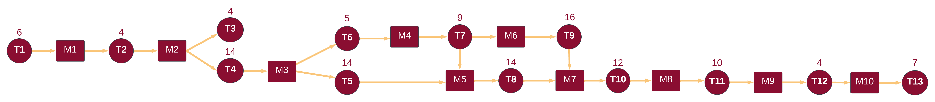

Figure Pert diagram

## 1.9 Report Outline:

**Chapter one** shows the project motivation is in Section 1.1; in addition, the problem statement is stated in Section 1.2, and Section 1.3 lists the project aim and objectives. In contrast, the project scope is identified in section 1.4; Section 1.5 provides the project software and hardware requirement, and Section 1.6 highlights the project limitation. Furthermore, the project’s expected output is addressed in Section 1.7, whereas the project is scheduled in Section 1.8, and the report outline is finally present in Section 1.9.

**Chapter two** the existing system is elaborated in Section 2.1; in addition, the overall problems of the current system are stated in Section 2.2, Section 2.3, general solution approach.

**Chapter three** establishesthe Feasibility Study in Section 3.1. The requirements gathering techniques defined in Section 3.2 The targeted users are stated in Section 3.3, Functional requirements definition specification are identified in Section 3.4, and Section 3.5 defines the non-functional requirements. In Addition, Usability and user experience goals in Section 3.6.

**Chapter four** shows the Architecture Diagram in Section 4.1. The ERD defined in Section 4.2. The Use case diagrams established in Section 4.3. Sequence Diagrams drawn in Section 4.4. Also, the database design is shown in Section 4.5.

# 2.0 Related Existing Systems

This section includes existing related works, their problems and what are the solutions for these problems, bearing in mind the scope and limitations of work.

## 2.1 Overview about existing systems:

1. [JoAcademy:](https://www.joacademy.com/home/intermediate) General Platform Provides online educational material including lectures, Quizzes, exams and slides. All these materials about the Jordanian educational programs.
2. [Open-Emis:](https://emis.moe.gov.jo/openemis-core/) Governmental Platform includes the student's data (Marks, Absences), it’s compulsory for each school to enter these data for all the students every semester. Also, the students or parents can see these data either through the [Open-Emis](https://emis.moe.gov.jo/openemis-core/) website or through [Sanad Platform](https://www.sanad.gov.jo/Default/AR) .
3. [JIS Website,](https://www.jis.edu.jo/facilities) [Kings Academy](https://www.kingsacademy.edu.jo/): Customized Websites for Jordanian Schools, the websites provide overall view about the school's achievements, facilities and events.

## 2.2 Problems of existing systems:

* The Generality of the Academy Platform make a lot of problems to the students specifically about lectures because the students will mis confused when studying from more than one resource ,for example the student feel comfortable about the school teacher teaching style but when he decide to make revision about a topic(for example) the Platform teacher will have another teaching style which will make misunderstanding for the student. Also, it doesn’t have the interactivity between the student and the teacher as well as with the parent and the teacher. In Addition, there’s no monitoring side for parents.
* Open-Emis Platform Allows the parents or students to show the marks and absences for the students just, no more functionalities due to that the monitoring side for the parents considered week as they just can see their children marks and absences without reports or anything that show their children performance.
* JIS, King Academy or any other school website considered as a general just for marketing purposes, there’s no interactions for parents or teachers or students across the website, due to that the students, parents and teachers won’t gain any benefit from that website.

## 2.3 Proposed solutions

Develop interactive website focuses mainly on the interactions between all Participants in the educational process, whether directly or indirectly, involving the parents inside the educational process by giving them reports about their children's behavior. Also, avoid the confusing of learning from Multiple sources the same teacher who teach the student at the school is the same at the website .Also, all the data needed for any one will be in one place so when the parent want to know something about his children it will be at the same website.

This website collects all the needed functionalities for anyone inside the educational process rather than show it from different resource.

# 3.0 SYSTEM REQUIREMENTS ENGINEERING AND ANALYSIS

This Chapter includes all the Feasibility study sides (Technical, Operational, Economic and Legal). Also, we defined the Stakeholders and the functional-nonfunctional requirements with brief description about them.

## 3.1 Feasibility Study

### 3.1.1 Technical Feasibility

The successful implementation of ILM-Verse depends on a comprehensive assessment of the technical resources, infrastructure, and compatibility with the school’s existing IT environment. This section outlines the key components required to ensure that the proposed solution is not only technically feasible but also scalable, secure, and adaptable to future needs

**Technology Stack**

The following technologies have been selected to ensure the E-Learning system for Thinking Flares School is robust, user-friendly, and capable of meeting the educational needs of all stakeholders:

|  |  |
| --- | --- |
| **Category** | **Technologies Used** |
| **Frontend Technologies** | **HTML, CSS, JavaScript, tailwind, React** |
| **Backend Technologies** | **Node.js, Express.js** |
| **DBMS** | **PostgreSQL, MongoDB** |
| **Security Technologies** | **SHA Algorithms, HTTPS** |

Table Technology Stack

### 3.1.2 Operational Feasibility

The ILM-Verse project is operationally feasible, as it aligns with the school’s goals, simplifies daily tasks, and enhances communication among stakeholders. Its user-friendly design and scalability make it a practical solution for TFS bearing in mind these criteria:

**1. Alignment with School Operations:**

The ILM-Verse project is designed to streamline and enhance the educational process at TFS. The system integrates smoothly into daily operations by:

1. Digitizing assignments, quizzes, and lectures, reducing manual tasks for teachers.
2. Providing parents the progress reports and communication tools, enhancing involve them inside the educational process.
3. Offering administrators tools to monitor and manage school activities efficiently, rather than manual management.

**2. Ease of Use for Stakeholders:**

The system features a user-friendly interface designed for:

1. Teachers: Simplified content creation, grading, reporting tools.
2. Students: Easy access to lessons, quizzes, and progress tracking.
3. Parents: Clear and timely updates on their children's performance.
4. Administrators: Comprehensive monitoring and communication tools.

**3. Resource Availability:**

The project must use just the available resources, including:

1. Development tools like Node.js, PostgreSQL, and Figma.
2. Existing school infrastructure such as laptops and internet connections.

**4. Training and Support:**

Minimal training is required due to the intuitive design of the system. Custom user manuals and video tutorials will be provided for each stakeholder group.

**5. Scalability and Maintenance:**

The system is scalable to accommodate the growing needs of the school. Regular updates and maintenance plans will ensure the platform remains functional and relevant.

### 3.1.3 Legal Feasibility

**1. Following Education Rules:**

The ILM-Verse project must follow Jordanian Ministry of Education rules. It should:

1. Match the Jordanian school curriculum(Collins Curriculums).
2. Protect student information like grades and attendance.

**2. Protecting Data and Privacy:**

The project must keep personal information safe and private by:

1. Encrypting sensitive data like grades, attendance, and personal information using SHA.
2. Using strong passwords and role-based access to ensure only authorized users (parents, teachers, and administrators) can view their data.
3. Getting clear user permission before collecting or using personal data.

**3. Hosting and Website Name:**

1. The platform must be hosted in compliance with Jordanian internet regulations.
2. The website domain name must use.**edu.jo**, which is mandatory for all educational institutions in Jordan.

**4. Protecting Content:**

1. The design, code, and learning materials should be protected under copyright laws.
2. We will Use only approved or self-created educational content to avoid legal issues.

**5. Contracts and Work Agreements:**

1. Clearly define roles and responsibilities for developers, teachers, and other contributors.
2. Ensure agreements state who owns the rights to the materials created.

**6. Honest Advertising:**

1. Avoid false claims about the platform’s benefits.
2. Ensure all marketing is accurate and follows local laws.

### 3.1.4 Economical Feasibility

**Development costs**

Personnel development costs:

|  |  |  |
| --- | --- | --- |
| Roles | Num of Employees | Cost (Whole Project) |
| Project manager | 1 | 1,750 JD |
| Developers | 4 | 4,000 JD |
| Testers | 2 | 1,200 JD |
| UI/UX design | 2 | 1,000 JD |
| Database admin | 1 | 1,500 JD |
| Total person cost | | 9,450 JD |

Table Personnel development costs

Hardware and Software Development Costs:

|  |  |  |
| --- | --- | --- |
| Hardware & Software Components | Quantity | Cost |
| Laptops with minimum 8GB RAM | 4 | 2,000 JD |
| Total | | 2,000 JD |

Table Hardware and Software Development costs

Operating costs:

|  |  |  |
| --- | --- | --- |
| Services | Quantity | Cost per Year |
| Internet Connection | 1 | 600 JD |
| Server | 1 | 1500 JD |
| Figma | 1 | 300 JD |
| Host name | 1 | 300 JD |
| Total | | 2,700 JD |

Table Operating costs

**Fixed and Variable costs:**

Fixed costs (Yearly):

|  |  |  |
| --- | --- | --- |
| Service | Quantity | Cost per Year |
| Internet Connection | 1 | 600 JD |
| Host name | 1 | 300 JD |
| Total | | 900 JD |

Table Fixed costs

Constant costs (for one time):

|  |  |  |
| --- | --- | --- |
| Service | Quantity | Cost |
| Development Team | 1 | 9,450 JD |
| Laptops with minimum 8GB RAM | 4 | 2,000 JD |
| Figma | 1 | 300 JD |
| Server | 1 | 1500 JD |
| Total | | 13250 JD |

Table Constant costs

For the Launching Year (Year 0) The Overall initial cost will be 14150 JD, after that the yearly fixed cost will be 900 JD. Also, the maintenance agreement will be 2000 JD for the first year after that each year the maintenance cost will increase 20%.

**Benefits**

Tangible Benefits:

|  |  |  |
| --- | --- | --- |
| Benefits | Description | Cost Per Year |
| Reduced Paper Costs | Transition to digital resources reduces expenses on printing, paper, and textbooks. | ≈ 3,000 JD |
| Time and Effort Saving | Automation of grading, reporting, and administrative tasks increases productivity. | - |
| Marketing Benefits | Attracts new students with enhanced communication and marketing features. | ≈ 7,000 JD |
| Total | | ≈ 10000 JD |

Table Tangible Benefits

**Intangible Benefits:**

* Enhanced Educational Quality: Improved teaching and learning processes through consistent access to digital resources and tools.
* Parent Engagement: Increased parental involvement with progress tracking and communication features.
* Efficiency and Convenience: Simplified workflows for teachers, parents and administrators reduce manual effort.
* Reputation Building: Establishes Thinking Flares School as a modern and innovative institution, enhancing its competitive edge.

**Payback Analysis:**

This Schedule includes the Payback analysis, each cost in this table considered as **JD** as well as each () value considered as minus.

|  |  |  |  |  |  |  |  |
| --- | --- | --- | --- | --- | --- | --- | --- |
| Year | Initial Costs | Operating Costs (Fixed) | Maintenance | Tangible Benefits | Cumulative Benefits | Net Benefit | Cumulative Net Benefit |
| **Year**  **0** | **14,150** | **0** | **0** | **0** | **0** | **(14,150)** | **(14,150)** |
| **Year**  **1** | **0** | **(900)** | **(2,000)** | **10,000** | **10,000** | **7,100** | **(7,050))** |
| **Year**  **2** | **0** | **(900)** | **(2,400)** | **10,000** | **20,000** | **6,700** | **(350)** |
| **Year**  **3** | **0** | **(900)** | **(2,880)** | **10,000** | **30,000** | **6,220** | **5,870** |
| **Year**  **4** | **0** | **(900)** | **(3,456)** | **10,000** | **40,000** | **5,644** | **11,514** |
| **Year**  **5** | **0** | **(900)** | **(4,147)** | **10,000** | **50,000** | **5,953** | **17,467** |

Table Payback Analysis

Over the First 5 Years:

Total benefits= 50000, Total Cost =33,533.

ROI ≈ ((Total benefits – Total Cost) / Total cost) *100

**ROI ≈ 49.1%.**

**Conclusion of Payback analysis:**

* The **payback period** is **3 years** because the cumulative net benefit becomes positive after Year3.
* The Return on Investment over 5 years is almost **49.1%**.

## 3.2 Requirements gathering techniques

### 3.2.1 Interviews

The goal of the interviews is to understand the expectations of school administrators regarding the ILM-Verse system and gather insights into the administrative processes, challenges, expectations and desired outcomes. This will ensure the system meets their needs effectively.

1. General Expectations

* What are your primary expectations from the ILM-Verse system?
* What are the main challenges you currently face in managing the school’s operations?
* How do you think the system improves communication among administrators, teachers, parents and students?

2. Administrative Processes

* Are there specific administrative tasks that are time-consuming or inefficient?
* How do you currently monitor the performance of teachers and students?
* Can you describe the current workflow for managing:

1. Student Records?
2. Teacher Schedules?
3. Parent Communication?

3. Communication and Collaboration

* What tools do you currently use for communication between administrators, teachers, and parents?
* What features do you think would improve communication within the school?
* How should the system handle announcements or urgent updates to stakeholders?

4. Tracking and Monitoring

* How do you currently track student performance (e.g., grades, attendance)?
* How do you track student engagement and participation in classes?
* What data points are the most important for you to track on a regular basis?

5. User Roles and Permissions

* How would you like to define user roles and Privileges within the system?
* Are there any specific actions that you’d like to restrict to certain roles?

6. Desired Features

* What features would you consider essential for the ILM-Verse system?
* What level of customization do you need for reports or system functionality?

7. Technical Considerations

* How comfortable is your team with using digital platforms? Do you foresee a need for training?
* Do you have specific preferences regarding system scalability and security?

### 3.2.2 Questionnaires

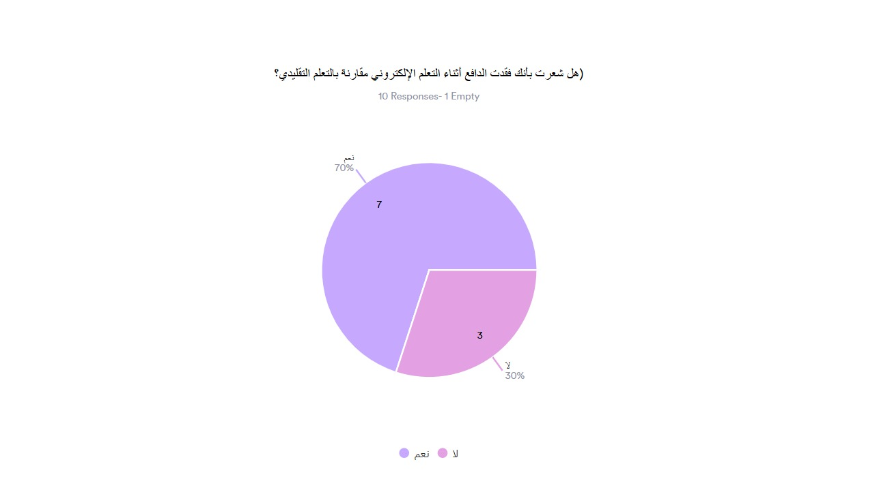

Figure Questionnaires 1

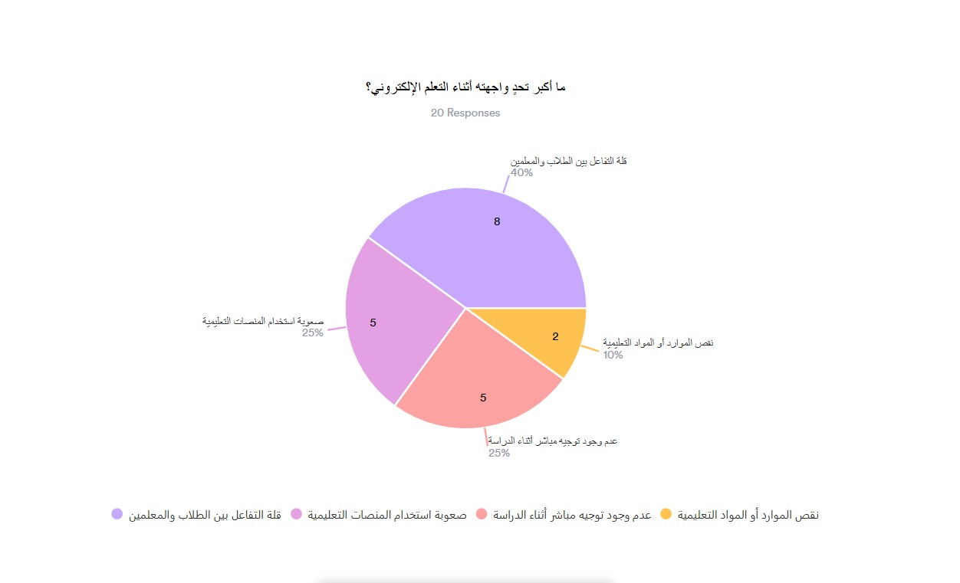

Figure Questionnaires 2

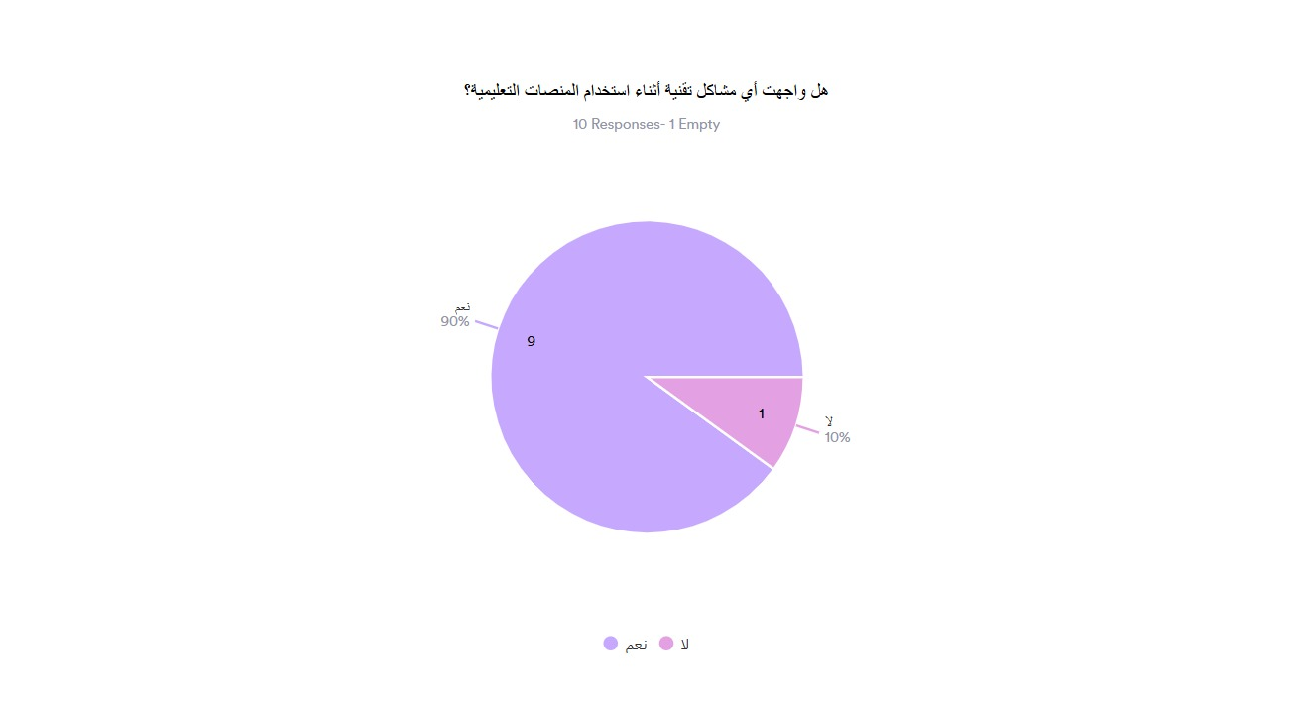

Figure Questionnaires 3

Figure Questionnaires 4

Figure Questionnaires 5

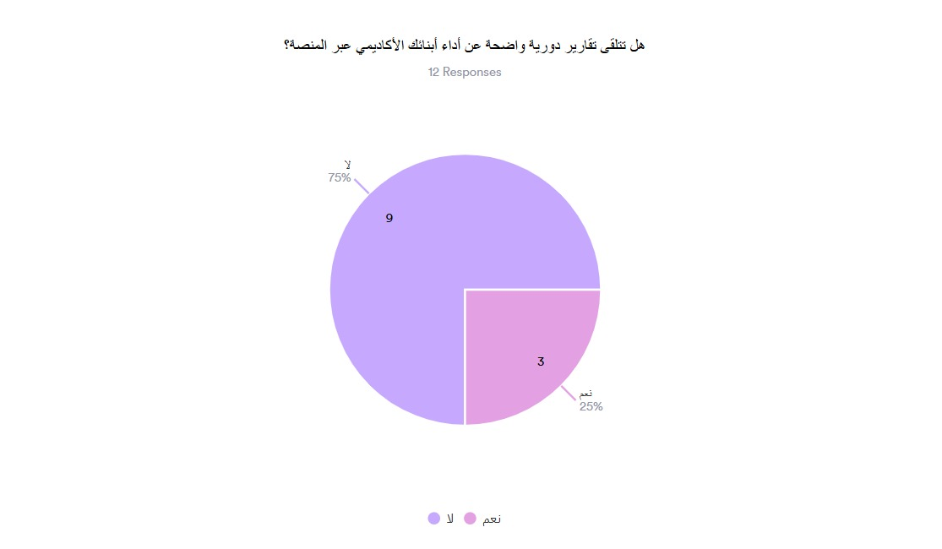

Figure Questionnaires 6

Figure Questionnaires 7

Figure Questionnaires 8

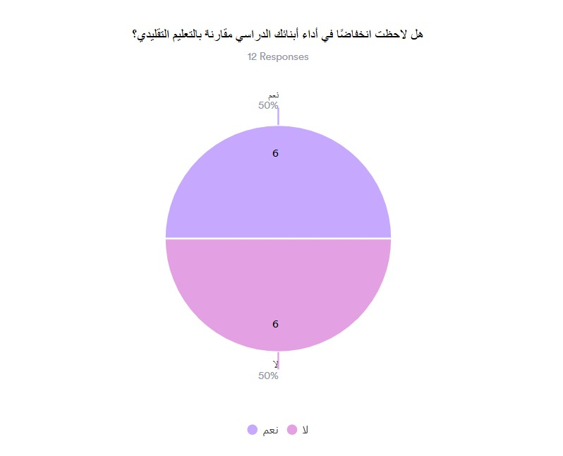

Figure Questionnaires 9

Figure Questionnaires 10

## 3.3 The targeted users (Stakeholders)

1. Teachers (ST1):

* **Responsibilities**:
  + Creating and managing lesson plans, assignments, and quizzes.
  + Grading and providing feedback to students.
  + Communicating with students and parents for updates and collaboration.
* **Features**:
  + Content Management Tools (assignments, lectures, quizzes).
  + Grading and assessment system.
  + Communication system (messaging, announcements).
  + Scheduling tools for lessons and classes.

2. Parents (ST2):

* **Responsibilities**:
  + Monitoring their child’s academic progress and performance.
  + Communicating with teachers and school administrators.
  + Receiving regular progress reports and performance feedback.
* **Features**:
  + Access to student performance dashboards.
  + Weekly/Monthly Progress Reports.
  + Direct messaging with teachers, Department Managers.
  + Notification system for important updates (grades, attendance, events).

3. Students (ST3):

* **Responsibilities**:
  + Engaging with course materials, submitting assignments, and participating in assessments.
  + Tracking academic progress and performance.
  + Communicating with teachers and Department Manager.
* **Features**:
  + Access to lessons, assignments, and quizzes.
  + Progress tracking dashboards.
  + Interactive feedback and grading systems.
  + Messaging system for collaboration and communication.

1. Administrators: The Hierarchy of admins inside TFS School is:
   1. General Administrator (ST4): **Have the Highest validity**

* **Responsibilities:**
  + Manage the resources of the whole website for any grade when needed.
  + Communicating with teachers, students, parents either individually or with all at the same message
* **Features:**
  + The Ability to add, delete, manage any content or resource included in the website
  + Communication system (messaging, announcements).
  1. Department Manager (ST5):
* **Responsibilities:**
  + Manage the resources of specific Department for any grade or report n when needed.
  + Communicating with teachers, students, parents that the Manager belongs to either individually or with all at the same message
* **Features:**
  + The Ability to add, delete, manage any content or resource included in the website and belongs to Manager Department
  + Communication system (messaging, announcements).
  1. Secretary (ST6):
* **Responsibilities:**
  + Manage the resources of the website data including management of all the stakeholders (students, teachers, parents) Accounts.
  + Communicating with teachers, students, parents either individually or with all at the same message
* **Features:**
  + The Ability to add, delete, manage any Account or resource included in the website
  + Communication system (messaging, announcements).

## 3.4 functional requirements definition and specification

This table includes all main functional requirements with short description and notes for each one, all of these functional requirements will be translated into use case diagrams after that the result use cases will be transformed into sequence diagrams with detailed description.

|  |  |  |  |  |
| --- | --- | --- | --- | --- |
| FR | Name | Stakeholders | Description | Notes |
| FR1 | Log-in Staff | ST1, ST4, ST5, ST6 | Filling in Email and Password blanks then the system will check if the email or password exist in the database then will determine what is the User role and based on that the User will be redirected to the role home page. If the password or the email is wrong an error will be appeared | We have 4 Roles:  1- General Manager  2- Department Manager  3- Teacher  4- Secretary |
| FR2 | Log-out | All | By clicking on the logout button, the session will be destroyed, and the user will be redirected to the Log-in Page |  |
| FR3 | Add Teacher | ST6 | The Secretary can add new Teachers, bearing in mind that all the teacher data should be included | Teacher data is:  1-full name  2-email  3-password  4-Department  5- Class.  6- Course. |
| FR4 | Add Student | ST6 | The Secretary can add new Student, bearing in mind that all the student data should be included | Student data is:  1- full name  2- national ID  3-password  4- Department  5-Class  6-Section |
| FR5 | Add Parent | ST6 | The Secretary can add new Parent, bearing in mind that all the parent data should be included | Parent data is:  1- full name  2- Phone Number  3- password  4- Children |
| FR6 | Delete Teacher | ST6 | The Secretary can Search for teacher by name or email and could delete that teacher from the system, after the deletion the teacher can’t use any of her functionalities and the teacher row in the Database will be deleted. | The Delete is permanent, the teacher must be deleted if and only if the teacher left the school. |
| FR7 | Delete Parent | ST6 | The Secretary can Search for parent by name or phone and could delete that parent from the system, after the deletion the parent can’t use any of his functionalities and the parent row in the Database will be deleted. | The Delete is permanent, the parent must be deleted if and only if the parent’s children left the school. |
| FR8 | Delete Student | ST6 | The Secretary can Search for student by name or National ID and could delete that student from the system, after the deletion the student can’t use any of his functionalities and the student row in the Database will be deleted. | The Delete is permanent, the parent must be deleted if and only if the student left the school. |
| FR9 | Change User Password | ST6 | Secretaries can change passwords for All stakeholders except general Manager by searching to them based on their full names or primary keys. |  |
| FR10 | View Course | ST1 | The Teacher can show her course/s, just the course who belong to the teacher should be appeared, any another course the teacher can’t view it, after that the teacher will have the ability to use the add or delete functionalities based on the course |  |
| FR11 | Add Assignment | ST1, ST5 | Teacher or Department Manager can upload Post including Assignment, with deadline and description about the assignment and any multimedia needed. The assignment should appear to all the students in the course | Multimedia for the Assignment can be:  1- Image  2- Audio  3- Video |
| FR12 | Add Files | ST1, ST5 | Teacher or Department Manager can upload Post that contains files about worksheets, Summaries and any other files needed for the studying process. The files should appear to all the students in the course. |  |
| FR13 | Add Lectures | ST1, ST5 | Teachers or Department Manager can upload Lectures to specific course, after uploading the Lecture should appear for students in the course. | The Video format must be only .mp4 |
| FR14 | Add Quiz | ST1, ST5 | Teachers or Department Manager can upload Quizzes and determine its durations, content, starting time, the grades for each question and the overall grade. | The quiz content must be multiple choice.  The Starting time includes the date and the starting time of the quiz |
| FR15 | Delete Content | ST1, ST4, ST5 | The Teacher and the Managers can delete any content from (lectures, quizzes, files ... etc.) to specific course, the teacher can only delete from her courses, and the department manager can delete from the courses that belongs to his department, the General Manager Can Delete from any course. | The Departments Are:  1- KG  2- Primary  3- Intermediate Males  4- Intermediate Females. |
| FR16 | Show Students | ST1, ST4, ST5 | This functionality shows all the students who belong to the chosen course. After that the Teacher or Manager can select the students to add reports or marks for that student. |  |
| FR17 | Add Marks | ST1, ST4, ST5 | The Teacher or Managers can Add marks for a specific student in a specific course. Based on pre-defined formula for different age groups.  The Department Managers can add marks only to the students who belong to Their Department. | The Age Groups and their formulas are:  1-KG’s and Primary Stage: 25/ 25 / 25 /25  2-Intermediate 4th-7th 20/20/20/40  3-Intermediate 8th –10th  40/40/40/80 |
| FR18 | Generate Report | ST1, ST4, ST5 | The Teacher or The Managers can Fill In formula report to specific student that belongs to specific course.  The Department Managers can generate report only to students who belong to their department | The Formula of The Report Includes:  1- Date: year/month/day  2- Description  3- Student Full Name  4- course name |
| FR19 | Edit Marks | ST4, ST5 | In this functionality  The General Manager can edit any mark to any student who belongs to a specific course.  The Department Managers can edit the marks just to the students who belongs to their department |  |
| FR20 | Search Student | ST4, ST5 | The Managers can search for a specific student based on his full name or national ID after that the student data will be shown.  Bear in mind that the Department Managers can search just for the students who belong to their department. | Student data includes:  Table that contains all the courses for that student as rows, each row has 3 buttons; the first one to show the student marks at that course, the second one to show the reports for that student in that course.  The third one to see the student absences |
| FR21 | Search Course | ST4, ST5 | The Managers can search to A specific course as Follows:  1- select the Class  2- select the Section  3- select the course  When the class have been selected, a table of sections for that class will be appear then the manager will choose the Section, after that a list of the courses which belongs to that section will be appeared, then the manager will choose the course who want.  Bearing in mind that the Department Managers can’t search for courses that don’t belong to their department. | 1-The Classes will be retrieved as a table each row considered as one class, and each row has a button to show the sections of that class.  2-The sections will be retrieved as a table; each row considered as a section and have a button to show the courses of that section.  3-The courses also will be retrieved as a table each row considered as a course and have a button to show that course. |
| FR22 | Add Secretary | ST4 | The General Manager can add a new secretary to the system bearing in mind fill all the required data for the secretary. After creation a new record will be added in the Data base | The Secretary Data Includes:  1- Full Name  2- Email  3- Password |
| FR23 | Delete Secretary | ST4 | The General Manager Can Delete existing secretary by showing all the secretaries and choose which secretary will be deleted | The Delete is permanent, the Secretary must be deleted if and only if the Secretary left the school. |
| FR24 | Forgot Password | All | Any user can change his password, and the process will be as the follows:  The User will fill the Username Data that may be email or Phone.  Then The System will determine the type of user and after that will send an OTP  The OTP will be sent by Email to Managers, Secretaries and Teachers, or by phone number to the Parents.  Then The User should fill the OTP, and the System must check if the OTP is correct or not if correct the user can change and confirm changing for his password if not an error will be appeared | The students can’t change their password, the only way to change their password is through the secretary.  The Error Message is: “Invalid OTP”. |
| FR25 | Student And Parent Log-in | ST2, ST3 | From home page the students or parents clicks on the login button, and redirected to the login page that contains 2 fields:  1- National ID or Phone Number  2- Password.  After filling the fields, the system will determine the user type (Parent or Student) and check if the user exists in the Database or not. If exists the user will be redirected to his own home page, if not an error message will appear. | In successful log-in the user must be redirected to his home page based on his role, the student for student home page and the parent to parent home page.  The Error Message is: “The Username or Password is Wrong” |
| FR26 | View Student Courses | ST2, ST3 | The Parents or Students can view the courses who belong to student.  The User should select the course who wants after that he will be redirected to the course page. | The courses will be retrieved as a table each row considered as a course and have a button to show that course. |
| FR27 | Upload File | ST3 | The student can upload a file to the activities that require a submission by clicking on a button called “submit”. | The file format must be either pdf or word |
| FR28 | Delete File | ST3 | If the student uploads a file a button called “remove submission” will appear to the student instead of the button “submit” and once the student clicks on it his submission will be deleted |  |
| FR29 | Download File | ST3 | The student can download the file uploaded by the teacher by clicking the “Download” button that appears below the file link |  |
| FR30 | View Grades | ST2, ST3 | In the course page the student or parent can see the grades for that student in that course. | Note that any non-filled data will be considered as 0 |
| FR31 | View Reports | ST2 | The parent can view the reports to his child in the chosen course. |  |
| FR32 | Show Absences | ST2 | The parent can view the Absences to his child from the starting date of the semester until the end of that semester | The absences data includes:  Number of absences  A table contains all the absences each row in that table considered as one absence and have the absence data. |
| FR33 | Send Announcement | ST4, ST5 | The General Manager Can Send Announcement to selected set of users or all the users.  The set of users considered as follows: 1- 4 checkboxes:  First one is All, when this choice selected all the other choices can’t be chosen  Second one is Teachers  Third one is Parents  Forth one is Students  After Selecting the targeted users also 4 checkboxes about the sections will appear:  1- KG  2- Primary  3- Intermediate Males  4- Intermediate Females  The Manager can choose just 3 choices.  Also the Department manager can choose the targeted users. However, the section will be checked already to the same section of the Department manager. |  |
| FR34 | Search by Name | All | For messaging system, all the users can search for other users by name, when the name does not exist a message will appear, if the user exists the system will check if the user who is searching can send message for the user searched for. If yes, the send message button will be able to be clicked, else a message will appear.  The System check if the user can send message or not as follows:  1- Students can send messages just for the teachers in same of their departments, department manager, General Manager and Secretary.  2- Parents can send messages just for the teachers in same of their children departments, department managers, General Manager and Secretary.  3- Department Managers can send messages for Secretary, General Manager as well as students and parents who belong to their department  4- General Manager and Secretary can send message to any user | The message for not founding the user is: “ the User is not found”.  The Message of the ability of sending message is false: “ You can’t send message for this user” |
| FR35 | Send Message | All | The message should include the Follows:  1-Sender  2-Receiver  3-Message content(text)  4-Message Timestamp  When the user clicks on send message, the message will be directed to the receiver inbox | Message Timestamp includes:  1- Date: year/month/day  2- Time:  Hour: Minute |
| FR36 | Receive Message | All | When The Message Sent Successfully, the message inbox will show the number of notifications (each conversation has a new message considered as (1) whatever how much the messages in that conversation, the User can show his inbox | The inbox section includes all the started conversations |
| FR37 | Add Post | ST4, ST5 | Managers can Add post in the posts section, the Post must include multimedia (Images, videos) with or without Description, The Filter in posts page gives the priority to the newest posts. | In the database record the post table must include:  1-Date:  Year/month/day  2-Time:  Hour: Minute  3-Description  4- Multimedia |
| FR38 | Delete Post | ST4, ST5 | Managers can Delete Specific post, when the post deleted the post shouldn't be appeared in the post Section. |  |
| FR39 | Edit Post | ST4, ST5 | Managers can edit specific posts, they can edit the description, remove or add multimedia. |  |

Table Functional Requirements definition and specification

## 3.5 Non-functional requirements

|  |  |
| --- | --- |
| NFR ID | Description |
| NFR 1 | **Performance:** The system should handle a growing number of users efficiently (students, teachers, parents, and administrators). |
| NFR 2 | **Scalability**: The system must be scalable to support an increasing number of users and growing data over time without performance degradation.  Should accommodate up to 500 concurrent users during peak usage times |
| NFR 3 | **Availability**: The system should maintain a minimum uptime of 99.5% to ensure continuous access for all stakeholders.  Scheduled maintenance and downtime should be communicated to all users at least 48 hours in advance. |
| NFR 4 | **Security**: The system must ensure the highest level of security with encrypted data storage and transfer.  Role-based access control (RBAC) must be implemented to limit access to sensitive information based on user roles (e.g., teacher, parent, student). |
| NFR 5 | **Usability**: The system should provide an intuitive and user-friendly interface that caters to users with varying levels of technical proficiency. The system must ensure a seamless experience across all platforms (web, mobile, tablets) with adaptive design for different screen sizes. |
| NFR 6 | **Compliance**: The system should adhere to Jordanian Ministry of Education standards and comply with local educational and data privacy laws.  The domain name must use **.edu.jo** to maintain educational credibility and meet local requirements. |

Table Non-functional requirements

## 3.6 Usability and user experience goals.

**Responsive Design:**

Provide a responsive interface that adapts to various screen sizes (desktops, tablets, smartphones), ensuring that all functionalities are easily accessible regardless of the device used.

**Accessibility:**

Ensure that the system supports accessibility features such as screen readers, text-to-speech, and keyboard navigation to provide a smooth experience for users with disabilities.

**Error Handling and Feedback:**

Offer clear, context-specific error messages and real-time feedback for actions such as form submissions, ensuring users can resolve issues efficiently.

**Consistency:**

Maintain a consistent look and feel across all sections of the system, including user interfaces, buttons, and form layouts, to provide a cohesive user experience.

**Personalization:**

Tailor the experience based on user roles (teachers, parents, students) by providing relevant data and actions in dashboards, based on role-based access and permissions.

**Engagement Features:**

Include interactive elements such as messaging systems, notifications, and real-time collaboration tools to enhance user engagement and interaction.

# 4.0 SYSTEM DESIGN

This Chapter includes the design and analysis of ILM-Verse functionalities by dividing them into sub-systems based on **OOAD**, the sub-systems will be presented in **Architecture Diagram** then each subsystem will have **Use case Diagram**. After that, each functional requirement in each use case will have **Table of Description and Sequence Diagram**. On the other hand, for database we are going to use **Relational and non-Relational Databases**, due to that the RDB needs **ERD** and the NRDB needs **JSON General Formula.**

## 4.1 Architecture Design

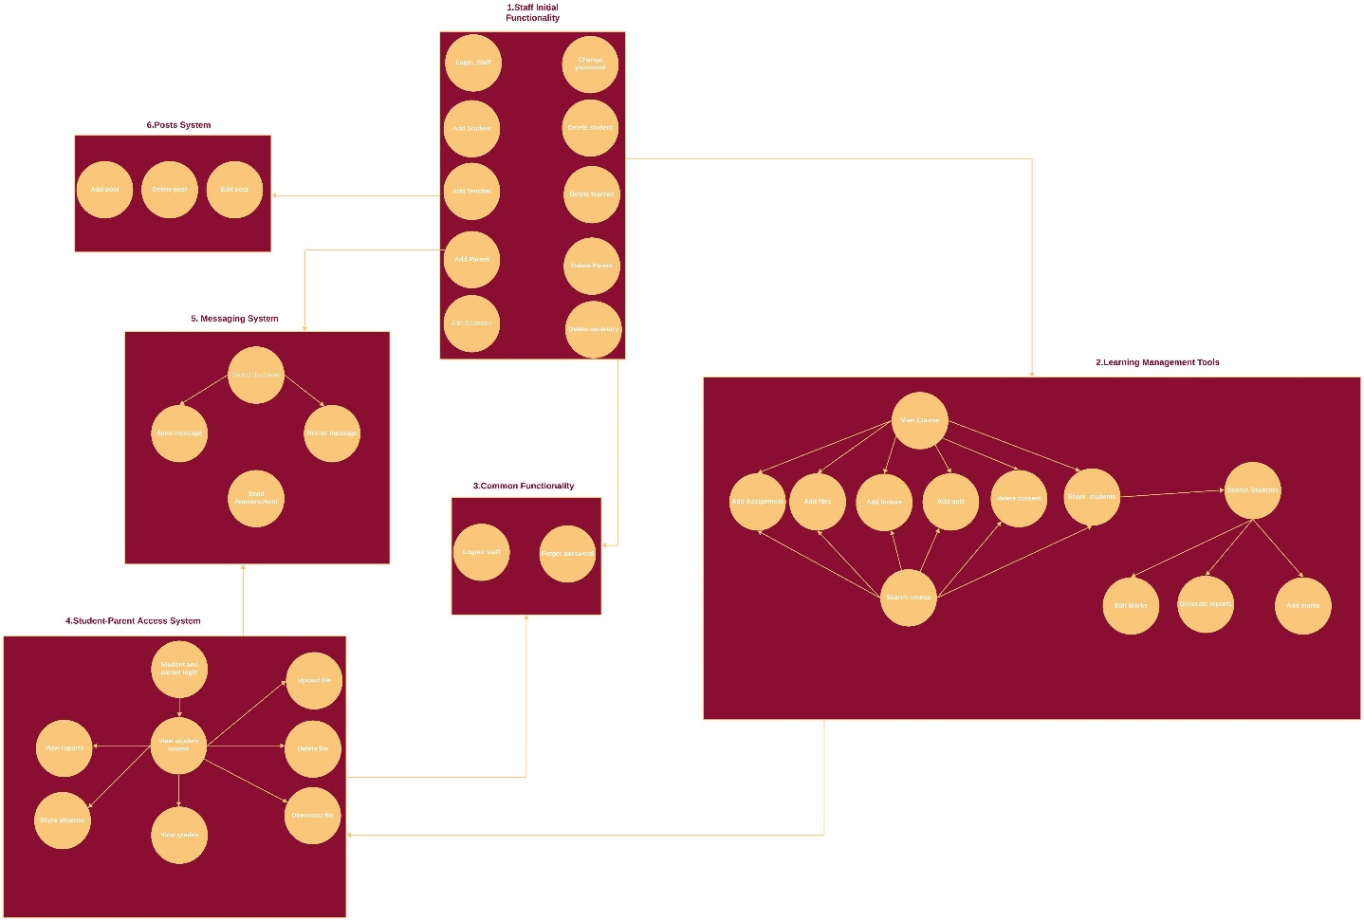

Figure Architecture Diagram

## 4.2 Entity Relationship Diagram (ERD)

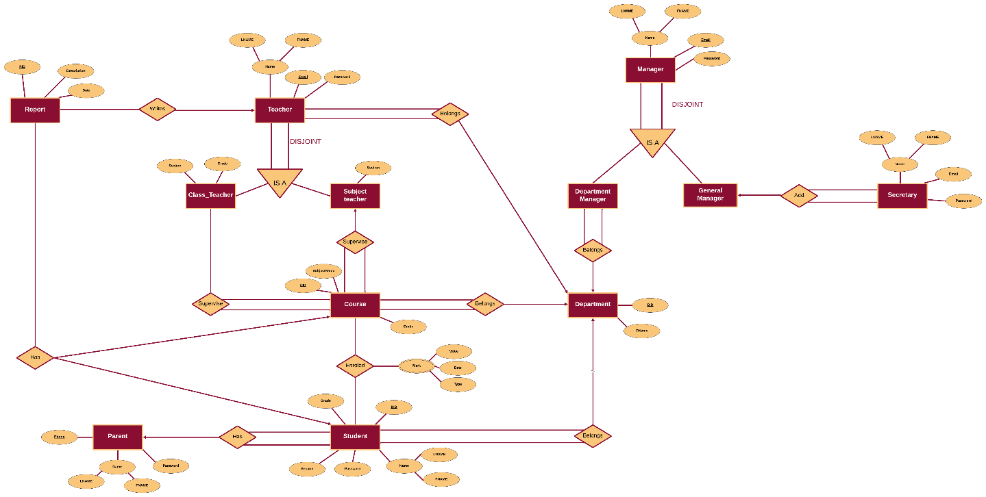

Figure ERD

## 4.3 UML Use Case Diagram

1-Staff initial functionality:

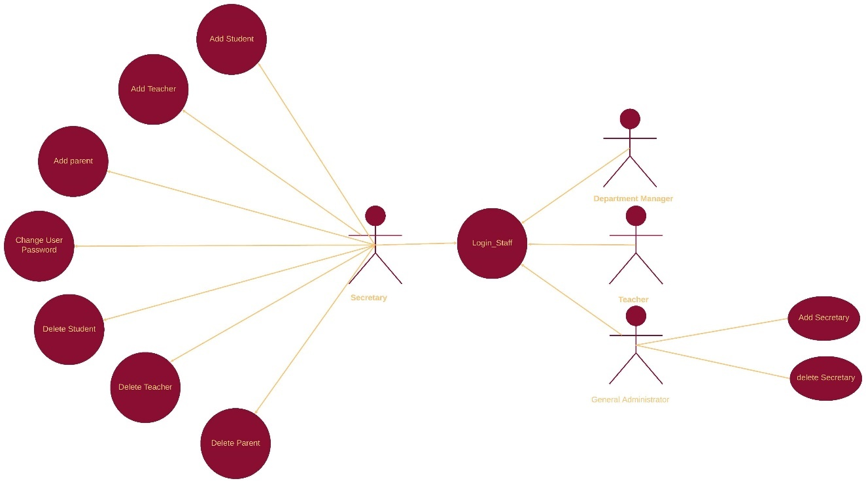

Figure USE CASE 1 STAFF INITIAL FUNCTIONALITY

2-Learning management tools:

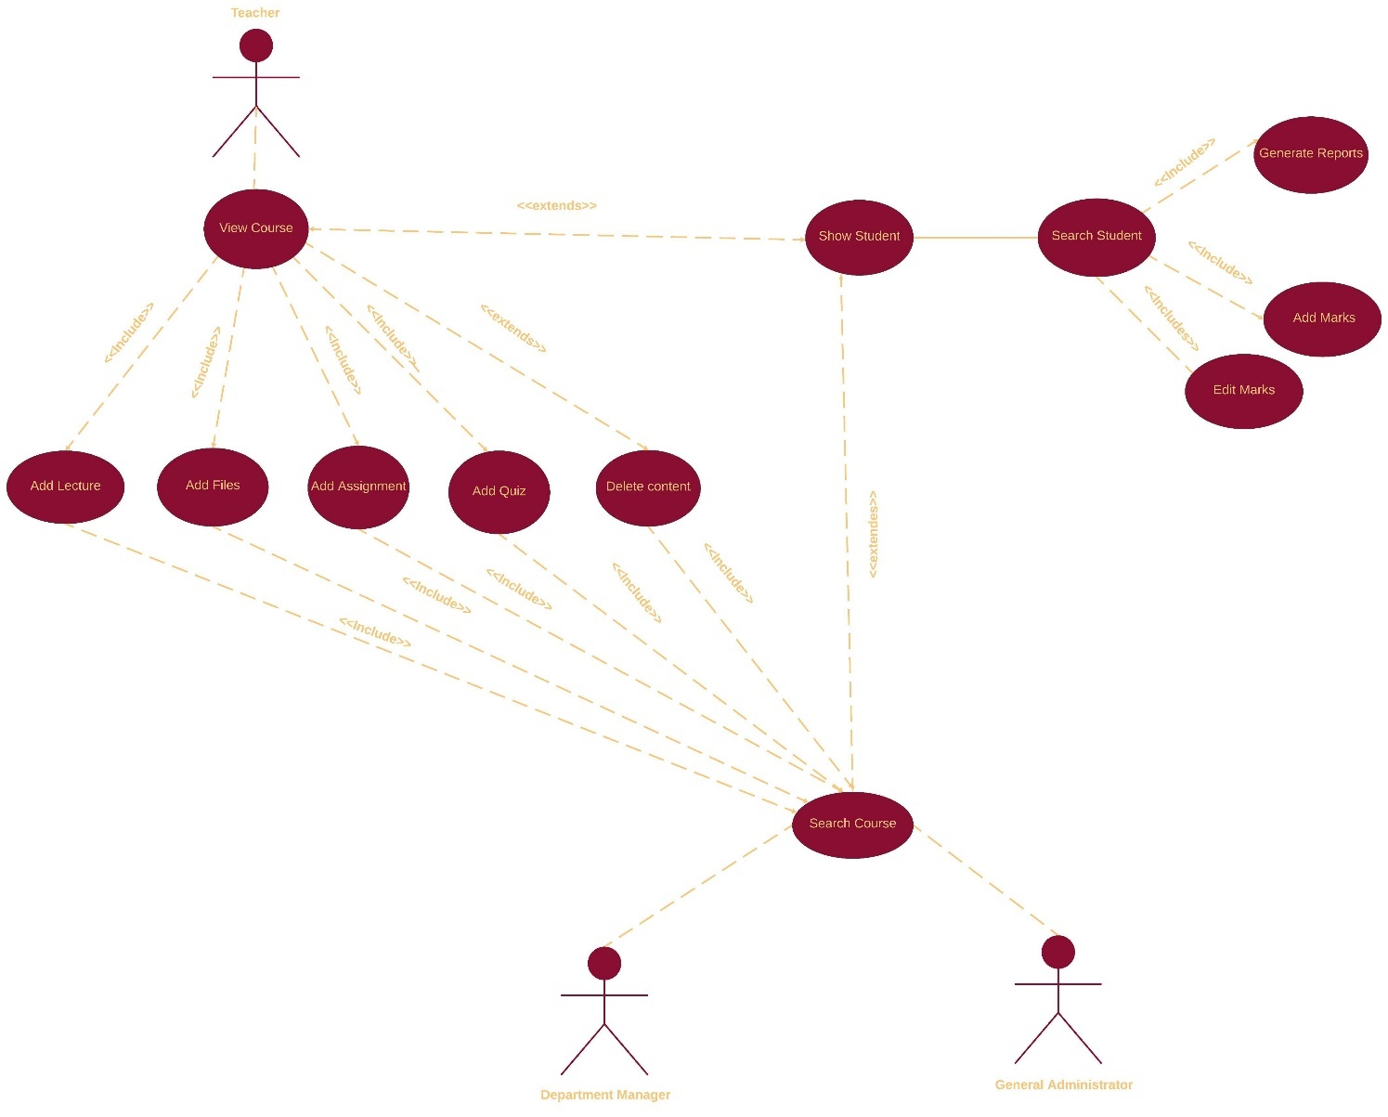

Figure USE CASE 2 Learning Management Tools

3-Common functionality:

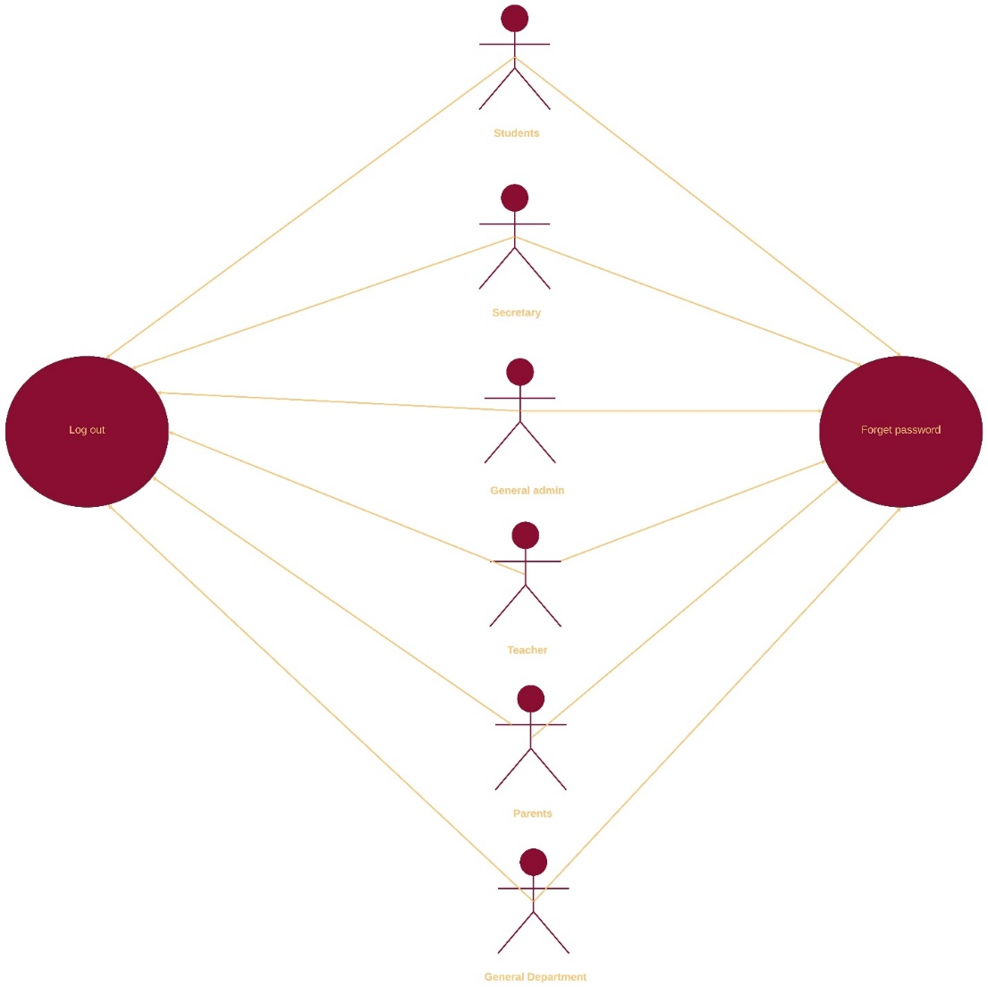

Figure USE CASE 3 Common Functionality

4-Student-parent access system:

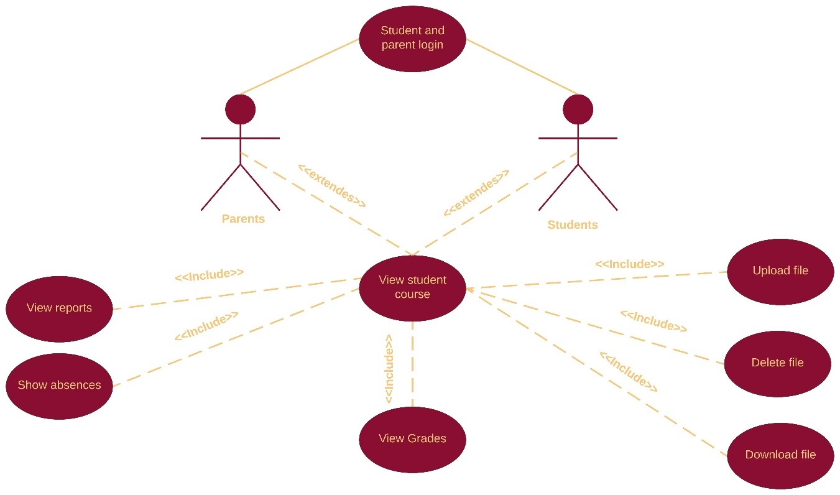

Figure USE CASE 4 Student-Parent Access System

5-Messaging system:

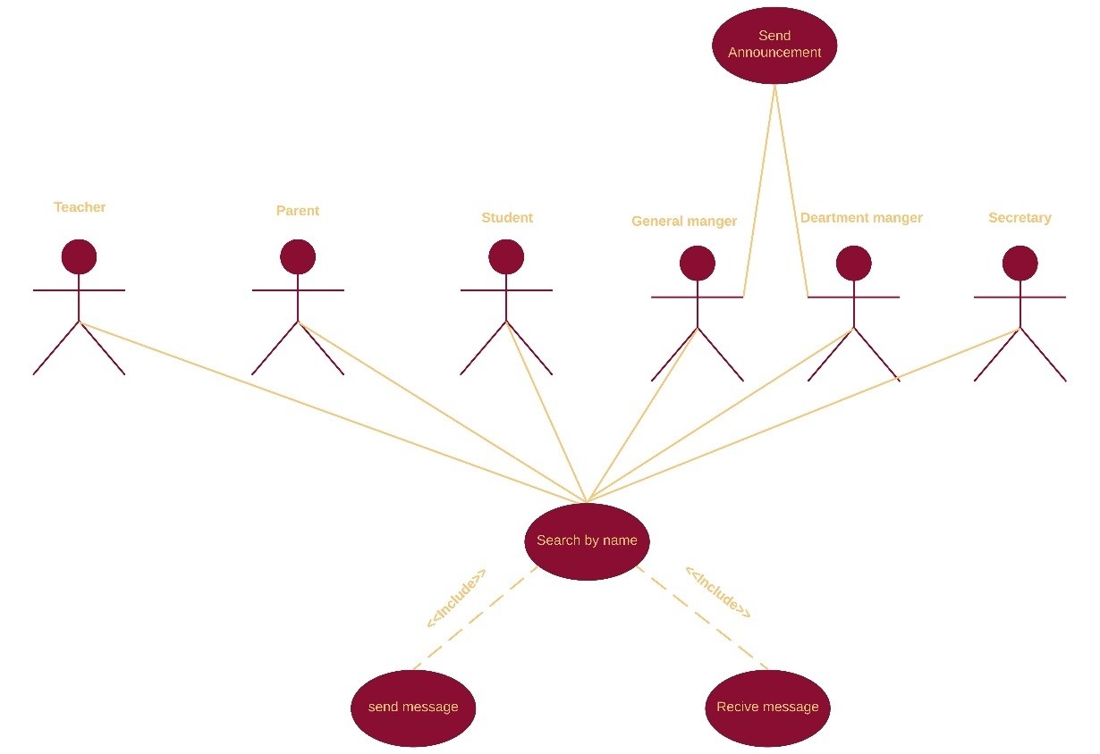

Figure USE CASE 5 Messaging System

6-Posts system:

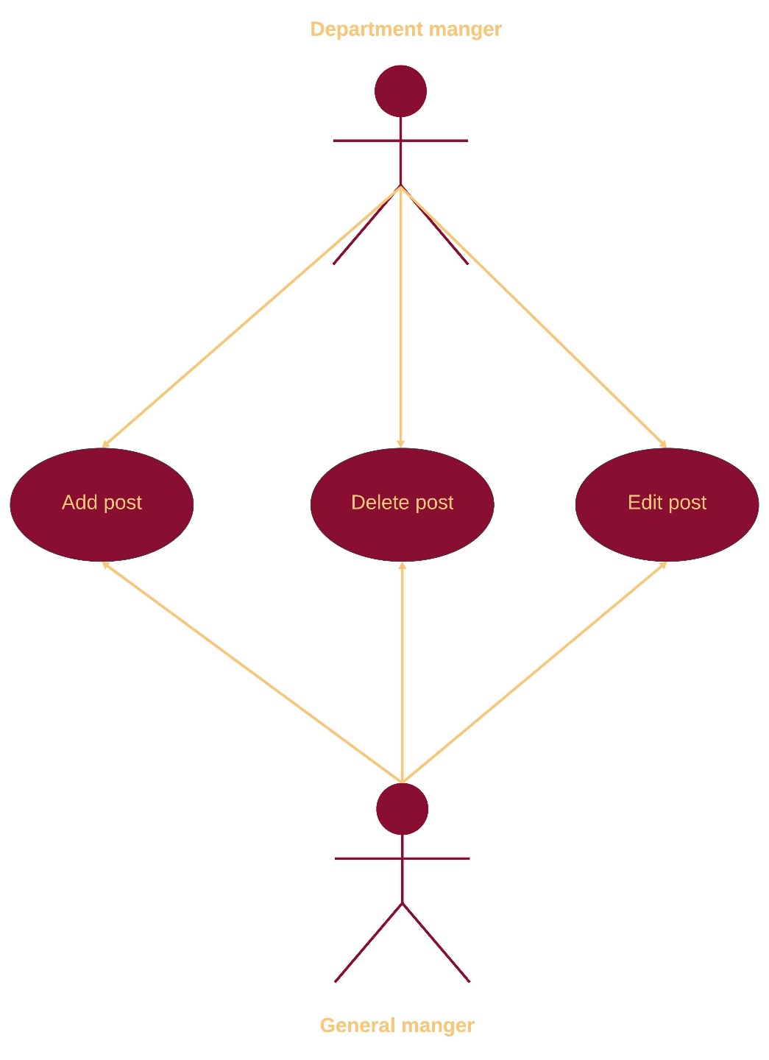

Figure USE CASE 6 Posts System

## 4.4 UML Sequence Diagram

G1: 1-Staff initial functionality:

|  |  |
| --- | --- |
| Log-in Staff | |
| Actors | Secretary, Department manager, Teacher, General manager |
| Description | The staff log-in functionality allows users to securely access the system by providing their email and password. The system validates these credentials by checking against the database. Upon successful authentication, the system identifies the user’s role (Secretary, Department Manager, Teacher, or General Manager) and redirects them to their designated role-specific homepage. If the entered email or password is incorrect, an error message is displayed, prompting the user to re-enter valid credentials |
| Data | 1- User Email  2-User Password  3-User Role (determined after authentication) |
| Stimulus | User enters their email and password into the login form. |
| Response | 1-If the credentials are valid, the user is logged in and redirected to the homepage corresponding to their role.  2-If the credentials are invalid, an error message (“Invalid email or password. Please try again.”) is shown. |
| Scenarios | 1-Successful Login:  a-The user enters a valid email and password.  b- The system verifies the credentials and determines the user’s role.  C-The user is redirected to their role-specific homepage.  Failed Login:  a-The user enters an incorrect email or password.  b-The system displays an error message and prompts the user to re-enter their credentials.  Account Does Not Exist:  a- The user enters an email not registered in the system.  b- The system displays an error message indicating the account does not exist.  Session Management:  a-Ensure the login form has proper validation to prevent SQL injection or other malicious activities.  b-Consider adding options for “Forgot Password” or “Register” to improve usability.  c-The system should handle user roles dynamically, allowing for scalable role additions or changes. |
| Comments | 1-Ensure the login form has proper validation to prevent SQL injection or other malicious activities.  2-Consider adding options for “Forgot Password” or “Register” to improve usability.  3-The system should handle user roles dynamically, allowing for scalable role additions or changes |

Table Log-in Staff Description

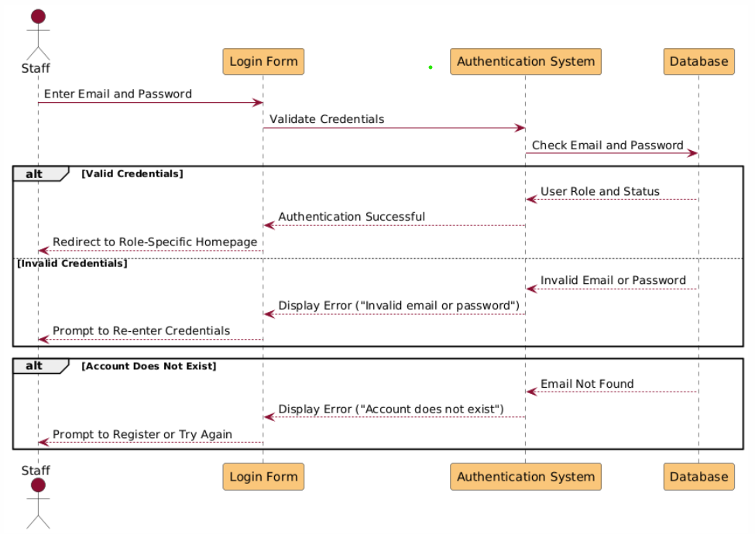

Figure Sequence Diagram 1 Login-Staff

|  |  |
| --- | --- |
| Add Teacher | |
| Actors | Secretary |
| Description | The secretary can add a new teacher by filling out the required details and submitting the information to the system. |
| Data | **Teacher Data**:  1. Full Name  2. Email  3. Password  4. Department  5. Class  6. Course |
| Stimulus | The secretary enters the teacher details and clicks the "Add Teacher" button. |
| Response | 1. Parent information is stored in the database.  2. A confirmation message is displayed to the secretary. |
| Scenarios | **Normal Scenario:**  a. Secretary fills out the form.  b. Secretary submits the form.  c. System saves the information and displays confirmation     |  | | --- | | **Error Scenario**  a. Secretary tries to submit incomplete or incorrect data.  b. System shows error messages like "All fields are required." | |
| Comments | - Only the Secretary role can add teachers.  - Teacher records must include all required fields. |

Table Add Teacher Description

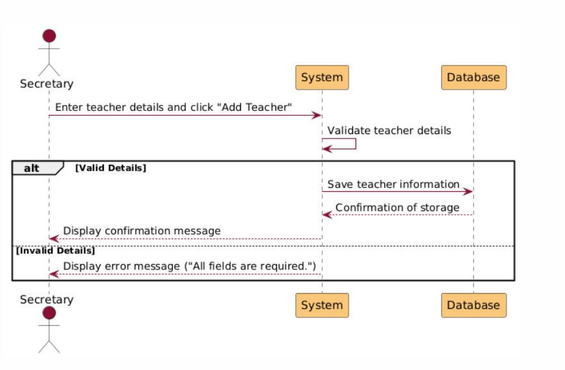

Figure Sequence Diagram 2 Add Teacher

|  |  |
| --- | --- |
| Add Student | |
| Actors | Secretary |
| Description | The Secretary can add a new student to the system by entering all the required details. |
| Data | 1. Full Name  2. National ID  3. Password  4. Department  5. Class  6. Section |
| Stimulus | Secretary fills out the form and clicks the "Add Student" button. |
| Response | 1. Student details are saved to the database.  2. A confirmation message is displayed. |
| Scenarios | **Normal Scenario**:  a. Secretary fills out the form.  b. Secretary submits the form.  c. System saves the details and displays confirmation.  **Error Scenario**:  a. Secretary submits incomplete or invalid data.  b. System displays an error message. |
| Comments | Validation ensures all required details are provided and correct before saving. |

Table Add Student Description

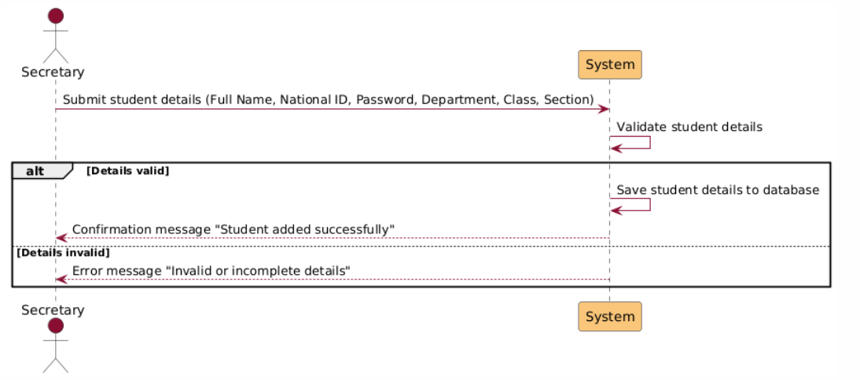

Figure Sequence Diagram 3 Student

|  |  |
| --- | --- |
| Add Parent | |
| Actors | Secretary |
| Description | The Secretary can add a new parent by filling out the required details and submitting the information to the system. |
| Data | Parent details including:  1. Full Name  2. Phone Number  3. Password  4. Associated Children |
| Stimulus | The secretary enters parent details and clicks the "Add Parent" button. |
| Response | 1. Parent information is stored in the database.  2. Confirmation message is displayed to the Secretary. |
| Scenarios | **Normal Scenario**:  a. Secretary fills out the form.  b. Secretary submits the form.  c. System saves the information and displays confirmation.  **Error Scenario**:  a. Secretary tries to submit incomplete data.  b. System shows error messages like "All fields are required." |
| Comments | Only the Secretary role can add parents. The parent's record should be complete and associated with at least one child. |

Table Add Parent Description

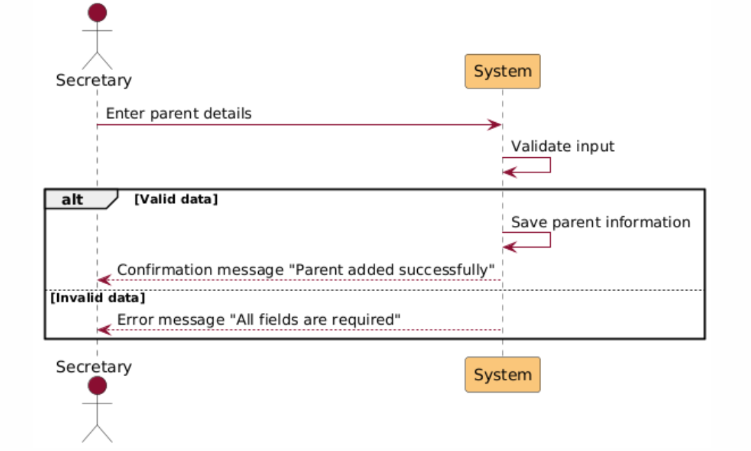

Figure Sequence Diagram 4 Add Parent

|  |  |
| --- | --- |
| Delete Teacher | |
| Actors | Secretary |
| Description | The Secretary searches for a teacher using their name or email, confirms the action, and deletes the teacher from the system. |
| Data | Teacher details:  1. Name or Email (for search)  2. Confirmation for deletion. |
| Stimulus | Secretary clicks the "Delete" button after searching and selecting a teacher. |
| Response | 1. Teacher is removed from the database.  2. Confirmation message is displayed. |
| Scenarios | **Normal Scenario**:  a. Secretary searches for a teacher.  b. Secretary confirms deletion.  c. System removes the teacher and shows confirmation.  **Error Scenario**:  a. Secretary searches for a non-existent teacher.  b. System displays an error message like "Teacher not found." |
| Comments | The deletion is permanent and applies only if the teacher has officially left the school. |

Table Delete Teacher Description

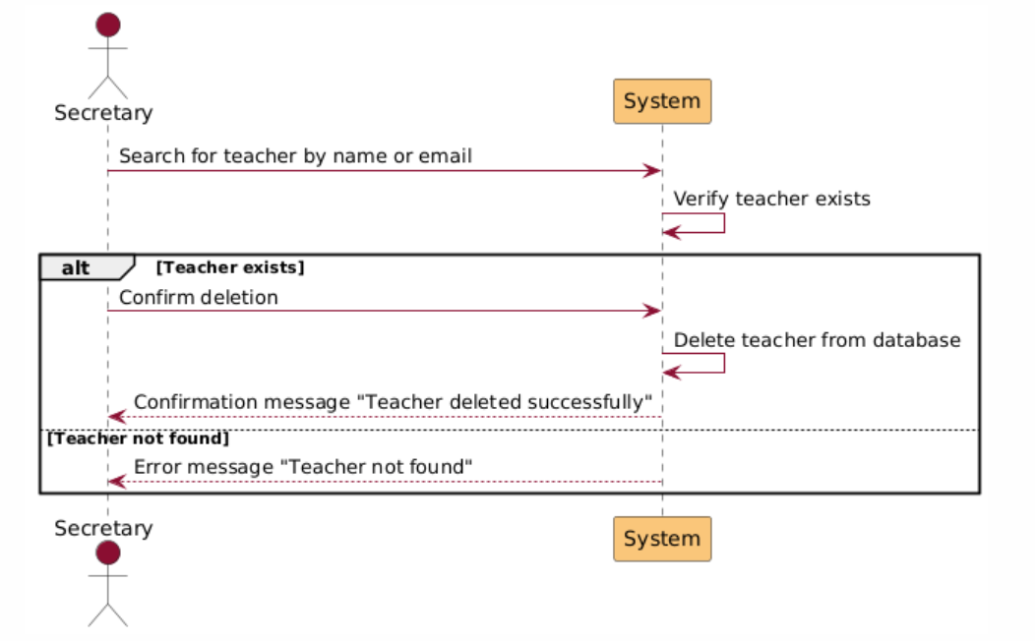

Figure Sequence Diagram 5 Delete Teacher

|  |  |
| --- | --- |
| Delete Parent | |
| Actors | Secretary |
| Description | The Secretary searches for a parent using their name or phone number, confirms the action, and deletes the parent from the system. |
| Data | Parent details:  1. Name or Phone Number (for search)  2. Confirmation for deletion. |
| Stimulus | Secretary clicks the "Delete" button after searching and selecting a parent. |
| Response | 1. Parent is removed from the database.  2. Confirmation message is displayed. |
| Scenarios | **Normal Scenario**:  a. Secretary searches for a parent.  b. Secretary confirms deletion.  c. System removes the parent and shows confirmation.  **Error Scenario**:  a. Secretary searches for a non-existent parent.  b. System displays an error message like "Parent not found." |
| Comments | The deletion is permanent and applies only if the child(ren) parent’s have left the school. |

Table Delete Parent Description

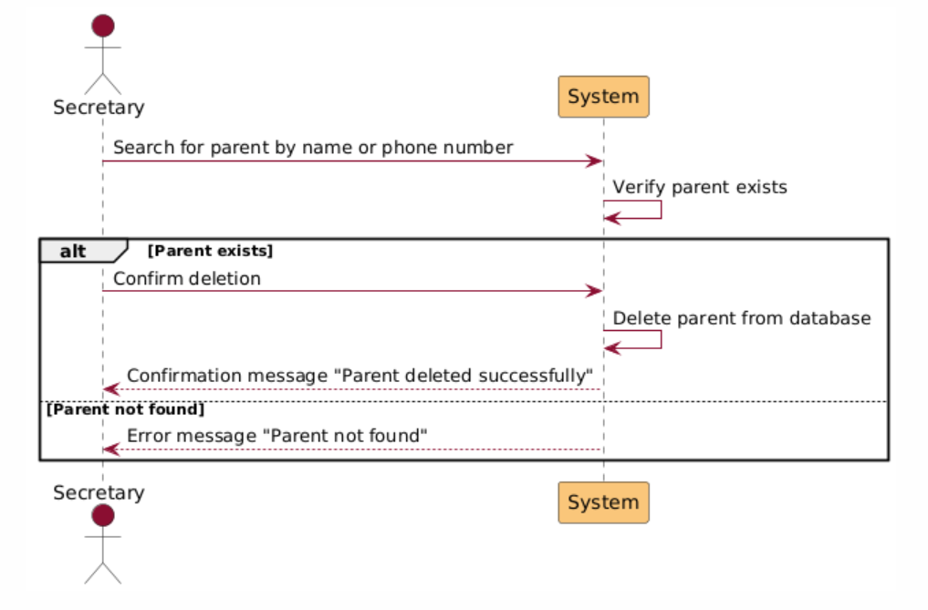

Figure Sequence Diagram 6 Delete Teacher

|  |  |
| --- | --- |
| Delete Student | |
| Actors | Secretary |
| Description | The secretary can delete a student's record from the system by searching for the student and confirming the deletion. |
| Data | **Student Details**:  - Full Name or National ID (for searching)  - Associated Class and Section. |
| Stimulus | The secretary searches for a student and clicks the "Delete Student" button. |
| Response | 1. The system removes the student's record from the database.  2. A confirmation message is displayed to the secretary. |
| Scenarios | - Normal Scenario  a. Secretary searches for a student by name or National ID.  b. Secretary confirms the deletion.  c. System deletes the student's record and displays a confirmation message.   * Error Scenario   a. Secretary attempts to delete a non-existent or already deleted student.  b. System shows an error message like "Student not found." |
| Comments | The deletion is permanent and should only be performed if the student has left the school. |

Table Delete Student Description

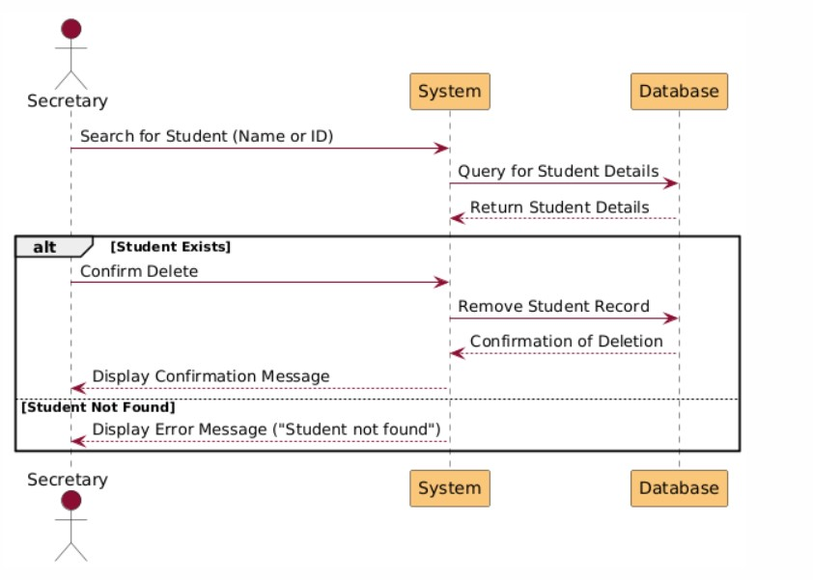

Figure Sequence Diagram 7 Delete Teacher

|  |  |
| --- | --- |
| Change User Password | |
| Actors | Secretary |
| Description | The Secretary searches for a user by their full name or primary key, updates the password, and saves the change. |
| Data | User details:  1. Full Name or Primary Key (for search)  2. New Password. |
| Stimulus | Secretary inputs the new password and confirms the change. |
| Response | 1. Password is updated in the database.  2. Confirmation message is displayed. |
| Scenarios | **Normal Scenario**:  a. Secretary searches for a user.  b. Secretary enters the new password.  c. System validates and updates the password.  d. Confirmation message is shown.  **Error Scenario**:  a. Secretary searches for a non-existent user.  b. System displays an error message like "User not found." |
| Comments | This functionality applies to all users except the General Manager, and the password must meet validation criteria. |

Table Change User Password Description

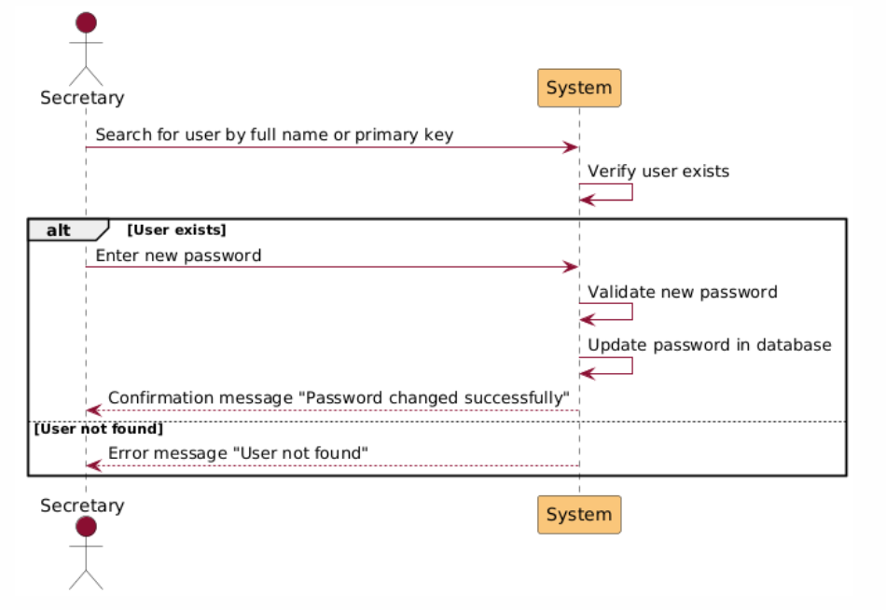

Figure Sequence Diagram 8 Change User Password

|  |  |
| --- | --- |
| Add secretary | |
| Actors | General Manager |
| Description | The General Manager can add a new secretary to the system by filling out all the required fields for the secretary's information. Once the data is provided and submitted, a new record is created and stored in the database.  Secretary data includes:  **1-**Full Name – The secretary's complete name.  2-Email – The email address for the secretary (used for login).  3-Password – A secure password for the secretary's account |
| Data | 1-Full Name  2-Email Address  3-Password |
| Stimulus | The General Manager accesses the "Add Secretary" form and inputs the required details. |
| Response | 1-If the data is valid, the system saves the new secretary's record in the database and displays a success message.  2-If the data is incomplete or invalid, an error message is displayed, prompting the manager to correct the inputs. |
| Scenarios | 1-Successful Addition:  a-The General Manager fills in the required fields (Full Name, Email, Password).  b-The system validates the inputs like(email format, password strength).  c-The record is saved in the database, and a success message is displayed.  2-Failed Addition – Incomplete or Invalid Data:  a-The General Manager attempts to submit the form with incomplete or invalid fields.  b-The system detects the issue and displays an error message like (“Email format is incorrect” or “Password must be at least 8 characters long”).  c-The manager corrects the inputs and resubmits the form.  3-Failed Addition – Duplicate Email:  a-The General Manager enters an email address already associated with another account.  b-The system displays an error message like(“Email address is already in use”).  c-The manager must provide a unique email address before submission. |
| Comments | 1- Ensure email addresses are validated for proper format and uniqueness.  2- Passwords should meet security requirements (minimum length, inclusion of numbers/special characters) |

Table Add Secretary Description

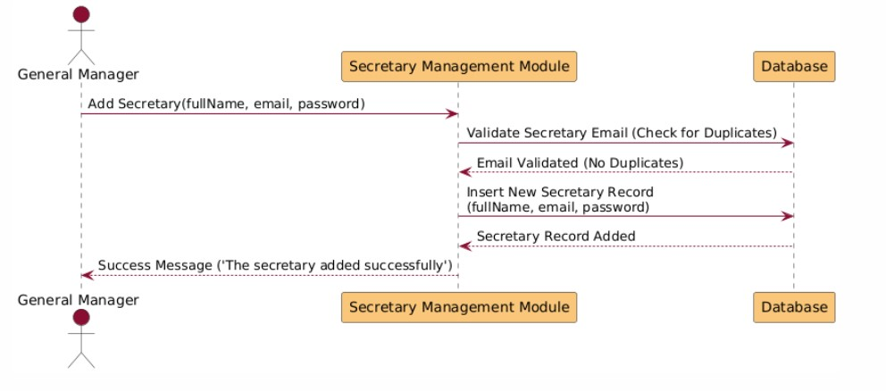

Figure Sequence Diagram 9 Add Secretary

|  |  |
| --- | --- |
| Delete secretary | |
| Actors | General Manager |
| Description | The General Manager can permanently delete an existing secretary from the system. The process involves displaying a list of all secretaries, allowing the manager to select and confirm which secretary will be removed. Deletion is irreversible and should only occur if the secretary has officially left the school. |
| Data | 1- Secretary ID  2-Full Name  3-Email |
| Stimulus | The General Manager selects the "Delete Secretary" option, views the list of secretaries, and chooses one for deletion. |
| Response | 1-If the secretary is selected and confirmed for deletion, their record is permanently removed from the database, and a success message is displayed.  2-If no selection is made or deletion is canceled, no changes occur. |
| Scenarios | 1-Successful Deletion:  a-The General Manager accesses the list of secretaries.  b-The manager selects a secretary to delete.  c-A confirmation dialog is displayed (“Are you sure you want to delete this secretary? This action is permanent.”).  d-Upon confirmation, the secretary’s record is permanently deleted from the database.  e-The system displays a success message (“Secretary successfully deleted.”).  2-Deletion Canceled:  a-The General Manager accesses the list of secretaries.  b-The manager selects a secretary but chooses not to confirm deletion.  c-The system cancels the operation without making changes.  3-Failed Deletion – Dependent Records Exist:  a-The manager attempts to delete a secretary with dependent records (linked to ongoing tasks or courses).  b-The system displays an error message (“Cannot delete this secretary as they are linked to active records. Please ensure all dependencies are cleared first.”). |
| Comments | 1-Ensure a confirmation step is mandatory before final deletion to avoid accidental removals.  2-Implement an audit log to record deletion actions, including the manager’s ID, the deleted secretary’s details, and the timestamp. |

Table Delete Secretary Description

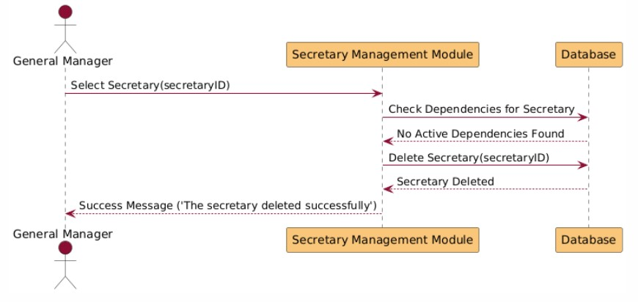

Figure Sequence Diagram 10 Delete Secretary

G2:Learning management tools

|  |  |
| --- | --- |
| View Course | |
| Actors | Teacher |
| Description | The Teacher can view a list of their assigned courses and select a course to see detailed information. |
| Data | Course information:  1. List of courses assigned to the teacher.  2. Details of the selected course. |
| Stimulus | The teacher requests to view their courses and selects one. |
| Response | 1. System fetches and displays a list of courses.  2. Displays details of the selected course. |
| Scenarios | **Normal Scenario**:  a. Teacher requests to view courses.  b. System fetches and displays the courses.  c. Teacher selects a course.  d. System retrieves and displays the course details.  **Error Scenario**:  a. Teacher has no assigned courses.  b. System displays a message like "No courses assigned." |
| Comments | Teachers can only view courses assigned to them, ensuring security and relevance. |

Table View Course Description

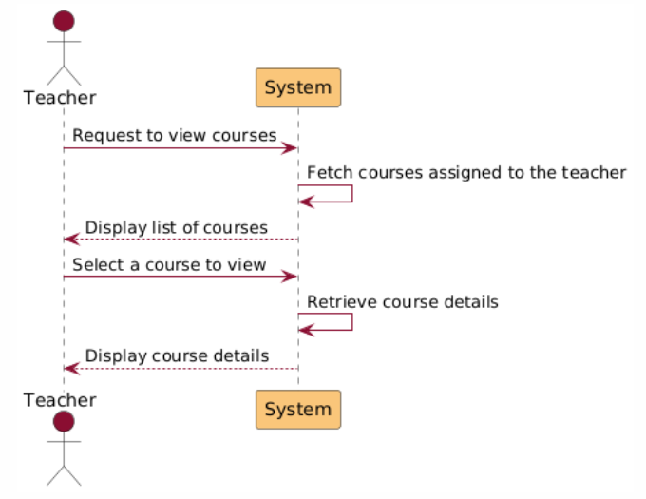

Figure Sequence Diagram 11 View Course

|  |  |
| --- | --- |
| Add assignment | |
| Actors | Teacher, Department Manager |
| Description | The teacher or the department manager can create and add a new assignment for a specific course, including details like description, deadline, and multimedia attachments. |
| Data | - **Assignment Details**:  - Title  - Description  - Deadline  - Multimedia (e.g., images, audio, video). |
| Stimulus | The teacher fills in the assignment details and clicks the "Add Assignment" button. |
| Response | 1. The assignment is stored in the database.  2. Students in the course can view the assignment. |
| Scenarios | * Normal Scenario   a. Teacher fills in the form with assignment details.  b. Teacher submits the form.   * Error Scenario   a. Teacher submits the form with incomplete or invalid data.  b. System shows error messages like "All fields are required" or "Invalid file format." |
| Comments |  |

Table Add Assignment Description

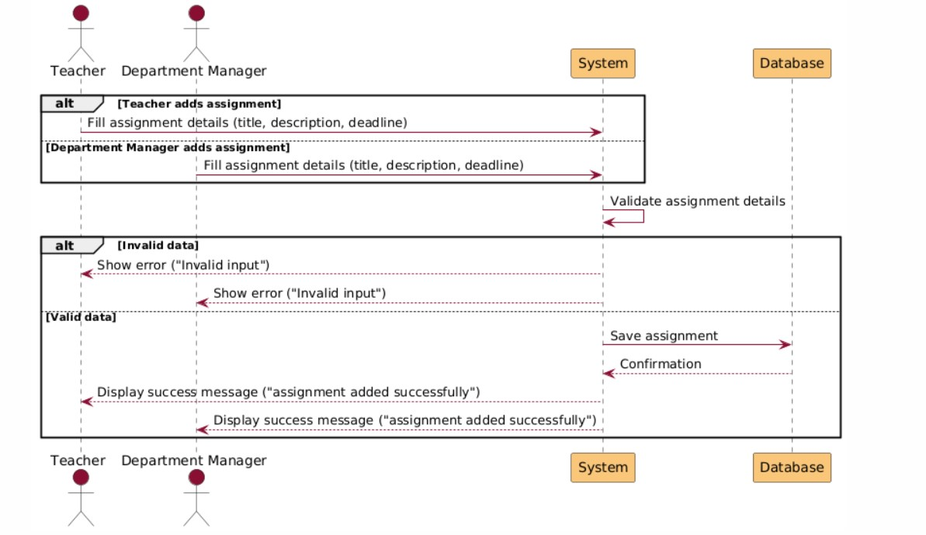

Figure Sequence Diagram 12 Add Assignment

|  |  |
| --- | --- |
| Add Files | |
| Actors | Teacher, Department Manager |
| Description | A Teacher or Department Manager can upload files (e.g., worksheets, summaries) to a specific course for students. |
| Data | File details:  1. Course to which the file is being added.  2. File name, type, and size. |
| Stimulus | User selects a course and uploads one or more files. |
| Response | 1. Files are saved to the system.  2. Confirmation message is displayed.  3. Error messages for invalid files or access denial. |
| Scenarios | **Normal Scenario**:  a. User selects a course.  b. User uploads valid file(s).  c. System saves file(s) and confirms the action.  **Error Scenario**:  a. User selects an invalid course.  b. System denies access.  c. User uploads invalid file(s).  d. System shows appropriate error messages like "Invalid file type or size." |
| Comments | Files must meet predefined criteria for type (e.g., .pdf, .docx) and size to ensure compatibility and efficiency. |

Table Add Files Description

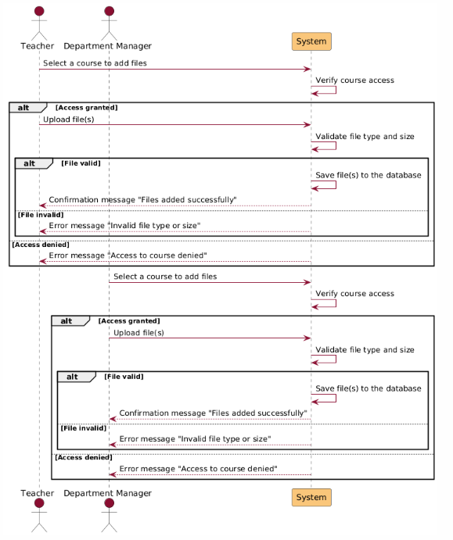

Figure Sequence Diagram 13 Add File

|  |  |
| --- | --- |
| Add Lectures | |
| Actors | Teacher, Department Manager |
| Description | A Teacher or Department Manager can upload lecture videos (e.g., pre-recorded lectures) to a specific course for students to access. |
| Data | Lecture details: 1. Course to which the lecture is being added. 2. Lecture title, description (optional). 3. Video file format and size (e.g., .mp4). |
| Stimulus | User selects a course and uploads one or more lecture videos. |
| Response | 1. Lecture files are saved to the system.  2. Confirmation message is displayed.  3. Error message for invalid video files or access denial. |
| Scenarios | **Normal Scenario:**  a. User selects a course.  b. User uploads valid lecture video file(s).  c. System saves file(s) and confirms the action.  **Error Scenario:**  a. User selects an invalid course.  b. System denies access.  c. User uploads invalid file(s) (e.g., incorrect format or exceeds size limit).  d. System shows appropriate error messages like "Invalid file type or size." |
| Comments | Files must meet predefined criteria for type (e.g., .mp4) and size to ensure compatibility and efficiency. |

Table Add Lectures Description

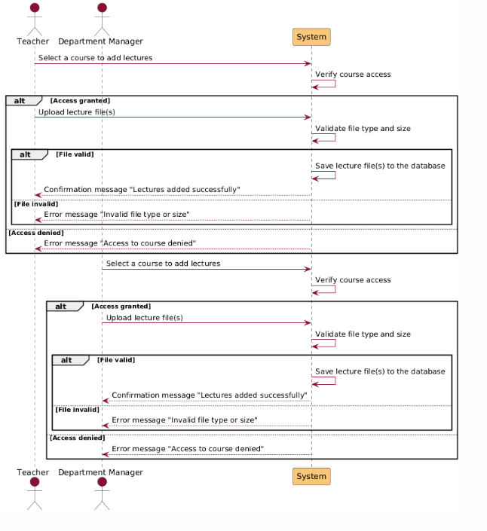

Figure Sequence Diagram 14 Add Lectures

|  |  |
| --- | --- |
| Add Quiz | |
| Actors | Teacher, Department Manager |
| Description | A Teacher or Department Manager can create and add quizzes to a specific course for students to complete as part of the curriculum. |
| Data | Quiz details: 1. Course to which the quiz is being added. 2. Quiz title, description (optional). 3. Questions, possible answers, correct answers, and scoring criteria. |
| Stimulus | User selects a course and creates a new quiz by adding questions and related information. |
| Response | 1. Quiz is saved to the system. 2. Confirmation message is displayed. 3. Error message for invalid input or access denial. |
| Scenarios | **Normal Scenario:**  a. User selects a course.  b. User provides valid quiz details (title, questions, answers, etc.).  c. System validates the input and saves the quiz. d. System shows a confirmation message "Quiz added successfully." **Error Scenario:** a. User selects an invalid course. b. System denies access. c. User provides invalid quiz details (e.g., missing fields or incorrect formatting). d. System shows an error message like "Invalid quiz details." |
| Comments | The system should validate the format and completeness of all fields before saving the quiz. |

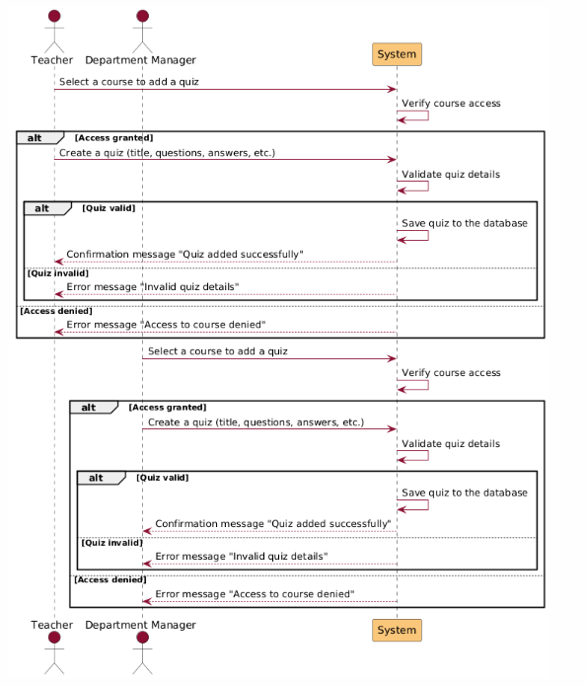Table Add Quiz Description

Figure Sequence Diagram 15 Add Quiz

|  |  |
| --- | --- |
| Delete content | |
| Actors | Teacher, General Manager, Department Manager |
| Description | This use case outlines the process for deleting content like (lectures, quizzes, files) from courses. The permissions for deletion are based on the user's role:  Teacher: Can delete content only from the courses they teach.  Department Manager: Can delete content from any course within their department.  General Manager: Has the authority to delete content from any course, across all departments.  Departments:  KG (Kindergarten)  Primary  Intermediate Males  Intermediate Females |
| Data | 1- Course ID  2-Content Type like (lecture, quiz, file)  3-User Role  4-Department (if applicable) |
| Stimulus | User selects the course and the specific content to delete. |
| Response | If the user has the appropriate permissions, the system deletes the selected content and displays a success message.  If the user lacks the necessary permissions, the system displays an error message (“You do not have permission to delete this content.”). |
| Scenarios | 1-Successful Deletion by Teacher:  a-The teacher selects content from a course they teach.  b-The system verifies their role and course association.  c-The content is deleted, and a success message is displayed.  2-Successful Deletion by Department Manager:  a-The department manager selects content from a course within their department.  b-The system verifies their role and department.  c-The content is deleted, and a success message is displayed.  3-Successful Deletion by General Manager:  a-The general manager selects content from any course.  b-The system verifies their role.  c-The content is deleted, and a success message is displayed.  4-Failed Deletion – Insufficient Permissions:  a-A user tries to delete content from a course they are not authorized to manage.  b-The system displays an error message and prevents the action.  4-Content Does Not Exist:  a-The user attempts to delete content that has already been removed or does not exist.  b-The system displays an error message indicating the issue. |
| Comments | Provide a confirmation dialog (“Are you sure you want to delete this content?”) to prevent accidental deletions. |

Table Delete Content Description

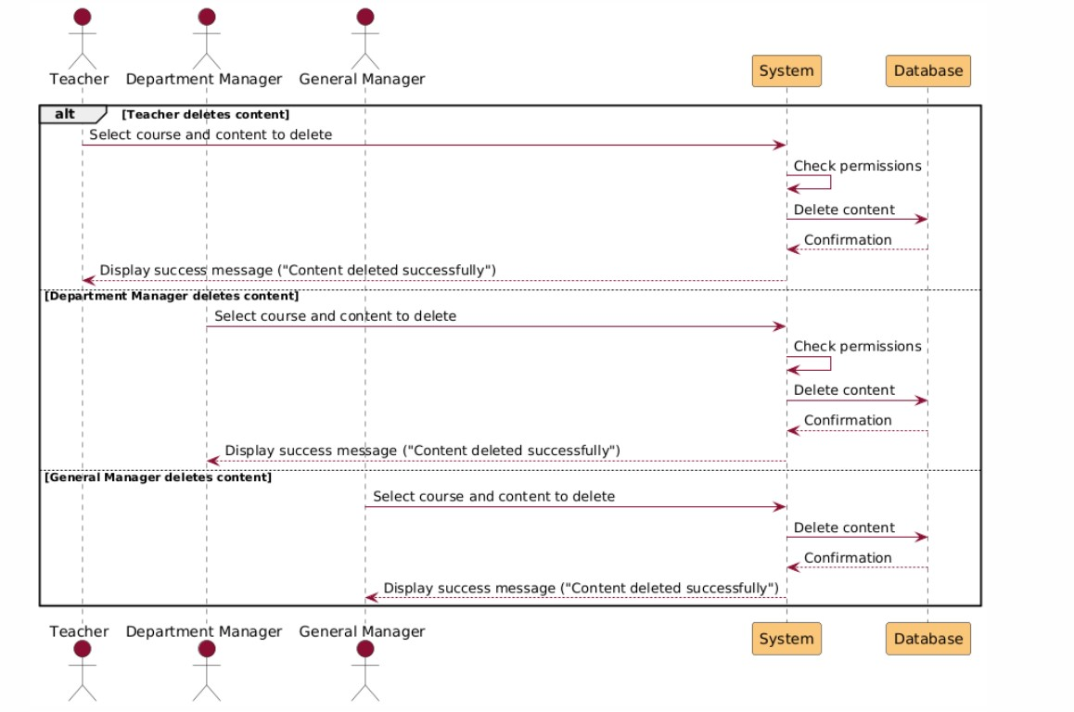

Figure Sequence Diagram 16 Delete Content

|  |  |
| --- | --- |
| Search Students | |
| Actors | General Manager, Department Manager |
| Description | Managers can search for a student by full name or National ID and view their information. |
| Data | 1. Full Name or National ID  2. Student Details (Courses, Marks, Reports, Absences) |
| Stimulus | Manager enters a search query and submits it. |
| Response | 1. Matching student details are retrieved and displayed.  2. Error message if no match is found. |
| Scenarios | **Normal Scenario**:  a. Manager submits a search query.  b. System retrieves matching student details.  c. Details are displayed.  **Error Scenario**:  a. Manager searches for a non-existent student.  b. System displays an error message. |
| Comments | Only authorized Managers can access student information. Department Managers are limited to their department. |

Table Search Students Description

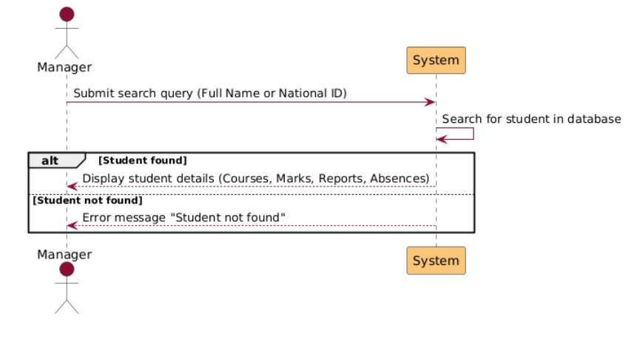

Figure Sequence Diagram 17 Search Student

|  |  |
| --- | --- |
| Show students | |
| Actors | Teacher, General Manager, Department Manager |
| Description | This functionality allows the user to view all students enrolled in a selected course. After displaying the list of students, the user (Teacher or Manager) can take specific actions, such as adding reports or assigning marks for individual students. |
| Data | 1-Course ID  2-Student List (retrieved from the database)  3-Actions like (Add Report, Assign Marks) |
| Stimulus | The user selects a course to view its enrolled students. |
| Response | The system retrieves and displays a list of students belonging to the chosen course.  The user can then interact with the list to perform further actions like adding reports or assigning marks. |
| Scenarios | 1-View Students in a Course:  a-The user selects a course.  b-The system fetches the list of students enrolled in the course.  c-The list is displayed, showing details such as student names and IDs.  2-Add a Report for a Student:  a-The user selects a student from the list.  b-The system provides an interface to create and submit a report for the selected student.  c-The report is saved, and a confirmation message is displayed.  3-Assign Marks to a Student:  a-The user selects a student from the list.  b-The system provides an interface to enter marks for the selected student.  c-The marks are saved, and a confirmation message is displayed.  4-Empty Course – No Students Enrolled:  a-The user selects a course with no students enrolled.  b-The system displays a message (“No students are currently enrolled in this course.”). |
| Comments | Actions like adding reports or assigning marks should have validation and confirmation to prevent accidental inputs. |

Table Show Students Description

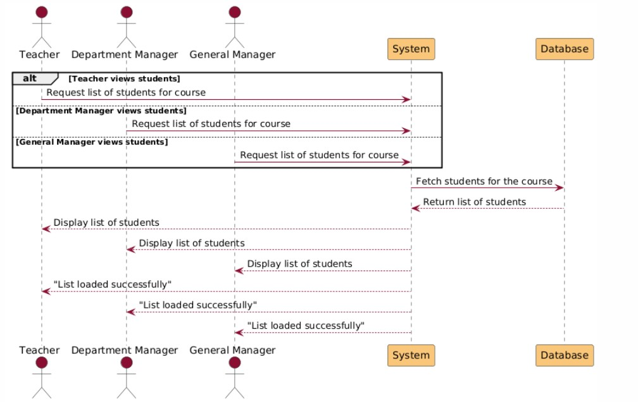

Figure Sequence Diagram 18 Show Students

|  |  |
| --- | --- |
| Add marks | |
| Actors | Teacher, General Manager, Department Manager |
| Description | This functionality allows Teachers and Managers to assign marks for specific students in a selected course. Marks are allocated according to predefined formulas based on the students' age group.  **1-Teacher:** Can assign marks only to students enrolled in their courses.  **2-Department Manager:** Can assign marks to students within their department.  **3-General Manager:** Can assign marks to any student in any department.  **Age Groups and Marking Formulas:**   1. **KG and Primary Stage:**    1. Components: 25 / 25 / 25 / 25    2. Total: 100 2. **Intermediate (4th–7th Grade):**    1. Components: 20 / 20 / 20 / 40    2. Total: 100 3. **Intermediate (8th–10th Grade):**    1. Components: 40 / 40 / 40 / 80    2. Total: 200 |
| Data | 1-Course ID  2-Student ID  3-Mark Components (Assignments, Quizzes, Exams, Participation)  4-Total Marks  5-User Role  6-Department |
| Stimulus | The user selects a course and a student to assign marks. |
| Response | If the user has appropriate permissions, the system provides the input fields for the applicable mark components based on the student’s age group and formula.  Marks are saved in the system, and a confirmation message is displayed. |
| Scenarios | 1-Add Marks by Teacher:  a-The teacher selects a course they teach and a student in the course.  b-The system identifies the student’s age group and presents the mark components based on the predefined formula.  c-The teacher inputs the marks and submits.  d-The system saves the marks and displays a success message.    2-Add Marks by Department Manager:  a-The department manager selects a course within their department and a student in that course.  b-The system verifies the manager’s role and retrieves the mark components based on the student’s age group.  c-The manager inputs the marks and submits.  d-The system saves the marks and displays a success message.    3-Add Marks by General Manager:  a-The general manager selects any course and a student in that course.  b-The system retrieves the mark components based on the student’s age group.  c-The manager inputs the marks and submits.  d-The system saves the marks and displays a success message.  4-Faild action:  a- if the marks are already entered |
| Comments | 1-Ensure the system validates input to prevent incorrect marks or exceeding the component limits.  2-Include a summary view for teachers and managers to review all entered marks before submission.  3-All actions should be logged for auditing purposes, including the user who entered the marks and the timestamp. |

Table Add Marks Description

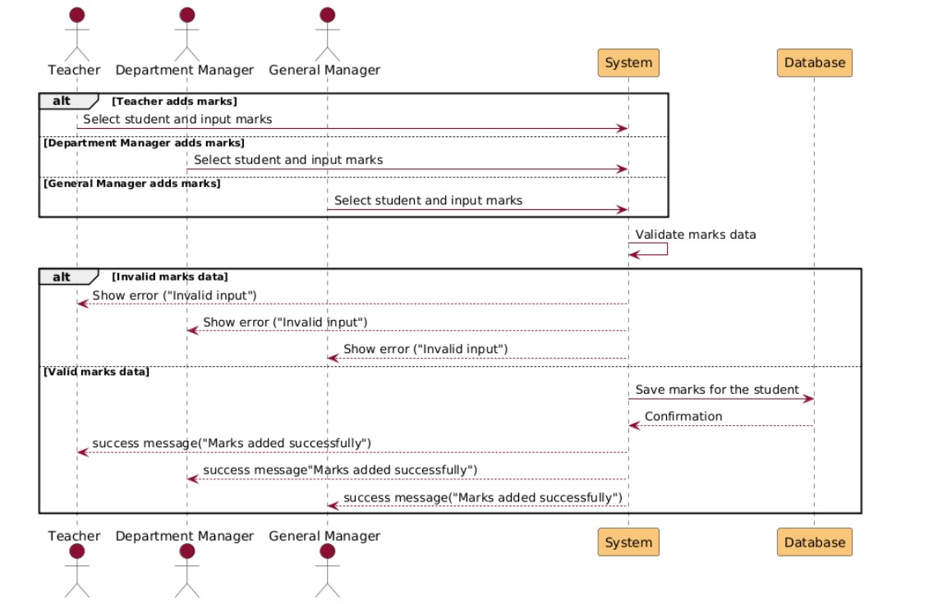

Figure Sequence Diagram 19 Add Marks

|  |  |
| --- | --- |
| Generate reports | |
| Actors | Teacher, General Manager, Department Manager |
| Description | This functionality allows Teachers and Managers to generate detailed reports for specific students in a selected course. Reports are created using a predefined formula and can only be generated  for students within the scope of the user's role:  Teacher: Can generate reports for students on the courses they teach.  Department Manager: Can generate reports for students within their department.  General Manager: Can generate reports for any student across all departments.  Report Formula Includes:  Date: Year/Month/Day  Description: Text description detailing the report’s purpose or findings.  Student Full Name: The complete name of the student.  Course Name: The name of the course the report is related to. |
| Data | 1-Course ID  2-Student ID  3-Report Details (Date, Description, etc.)  4-User Role  5-Department |
| Stimulus | The user selects a course and a student to generate a report. |
| Response | If the user has the appropriate permissions, the system provides a report template pre-filled with available data (e.g., student name, course name).  The user completes the report fields and submits it.  The system saves the report and provides an option to download or share it. |
| Scenarios | 1-Generate Report by Teacher:  a-The teacher selects a course they teach and a student in that course.  b-The system retrieves the student and course data, pre-filling the report template.  c-The teacher completes the description and date fields, then submits the report.  d-The system saves the report and displays a success message.    2-Generate Report by Department Manager:  a-The department manager selects a course within their department and a student in that course.  b-The system verifies their role and retrieves the necessary data for the report template.  c-The manager completes the description and date fields, then submits the report.  d-The system saves the report and provides an option to download or share it.  3-Generate Report by General Manager:  a-The general manager selects any course and a student in that course.  b-The system retrieves the necessary data and pre-fills the report template.  c-The manager completes the description and date fields, then submits the report.  d-The system saves the report and displays a success message.  4-Failed Action:  a-If the report already existed. |
| Comments | Include options for exporting the report as a PDF or Word. |

Table Generate Report Description

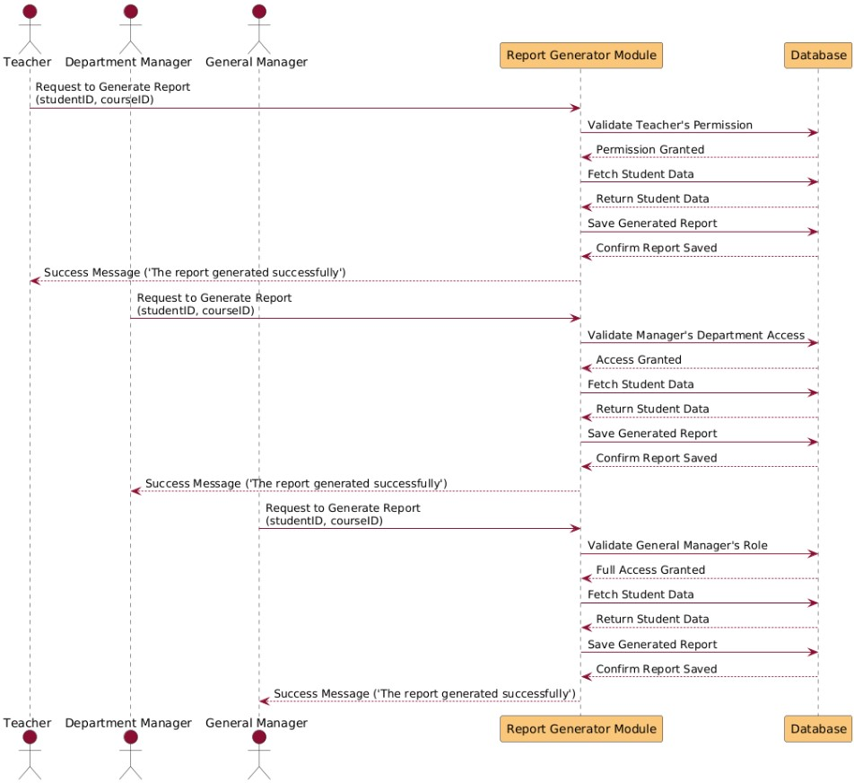

Figure Sequence Diagram 20 Generate Report

|  |  |
| --- | --- |
| Edit Marks | |
| Actors | General Manager, Department Manager |
| Description | The functionality allows the general manager to edit the marks of any student who belongs to a specific course.  The department manager can edit the marks of the students in their department only  **Age Groups and Marking Formulas:**   1. **KG and Primary Stage:**    1. Components: 25 / 25 / 25 / 25    2. Total: 100 2. **Intermediate (4th–7th Grade):**    1. Components: 20 / 20 / 20 / 40    2. Total: 100   **3. Intermediate (8th–10th Grade):**   * 1. Components: 40 / 40 / 40 / 80   2. Total: 200 |
| Data | 1-Course ID  2-Student ID  3-Mark Components (Assignments, Quizzes, Exams, Participation)  4-Total Marks  5-User Role  6-Department |
| Stimulus | The managers select the students and the course to edit |
| Response | If the managers has appropriate permissions, the system allows them to edit on the marks be showing them the old marks and an edit button based on the student’s age group and formula.  Then inserting the new mark on the input field instead of the old one and a submit the update  Updated Marks are saved in the system, and a confirmation message is displayed. |
| Scenarios | 1-Edit Marks by Department Manager:  a-The department manager selects a course within their department and a student in that course.  b-The system verifies the manager’s role and retrieves the mark components based on the student’s age group.  c-The manager edits the marks by clicking on the edit button.  d-The manager inserts the new marks and submits it.  e-The system saves the marks and displays a success message  2-Edit Marks by General Manager:  a-The general manager selects any course and a student in that course.  b-The system retrieves the mark components based on the student’s age group.  c- The manager edits the marks by clicking on the edit button.  d- The manager inserts the new marks and submits it.  e-The system saves the marks and displays a success message. |
| Comments |  |

Table Edit Marks Description

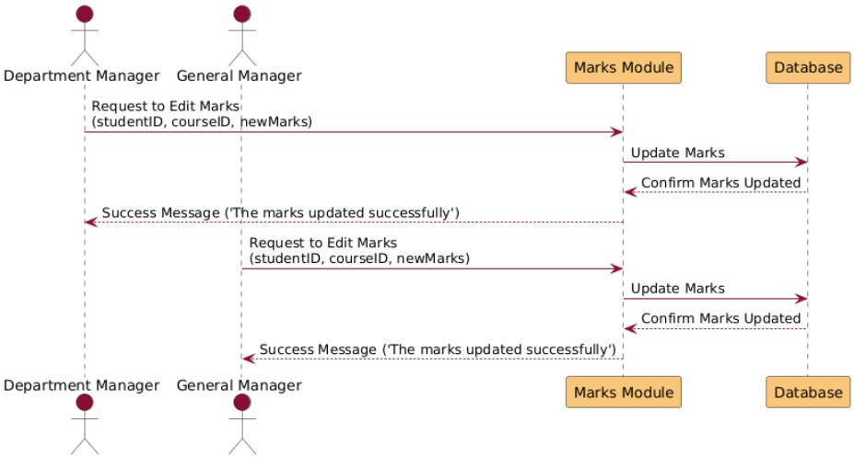

Figure Sequence Diagram 21 Edit Marks

G3: Common Functionality

|  |  |
| --- | --- |
| Log-out | |
| Actors | User (Student, Teacher, Parent, or General Manager) |
| Description | The user initiates the logout process by clicking the "Log Out" button. The system then destroys the user's session and redirects them to the login page. |
| Data | Session ID (used to identify and terminate the user session). |
| Stimulus | User clicks the "Log Out" button. |
| Response | 1. Session is terminated.  2. User is redirected to the login page. |
| Scenarios | a. User clicks the "Log Out" button.  b. System destroys the session.  c. User is redirected to the login page. |
| Comments |  |

Table Log-out Description

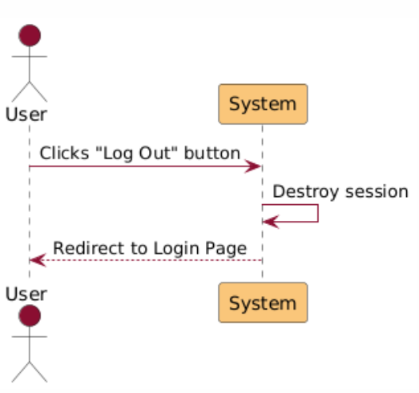

Figure Sequence Diagram 22 Log-out

|  |  |
| --- | --- |
| Forgot Password | |
| Actors | Student, Parent, Secretary, Teacher, General Manager, Department Manager |
| Description | The user initiates a password reset by providing their email or phone number, receives an OTP, and sets a new password. |
| Data | 1. User credentials (email or phone number).  2. OTP (One-Time Password).  3. New Password. |
| Stimulus | User requests to reset their password by clicking "Forgot Password." |
| Response | 1. System sends an OTP to the user.  2. Valid OTP allows the user to reset their password.  3. Error messages for invalid credentials or OTP. |
| Scenarios | **Normal Scenario**:  a. User provides valid credentials.  b. System sends OTP.  c. User enters valid OTP.  d. User resets password.  e. System confirms password reset.  **Error Scenario**:  a. User provides invalid credentials.  b. System displays "User not found."  c. User enters invalid OTP.  d. System displays "Invalid OTP." |
| Comments | OTPs are sent via email for Teachers, General Manager, Department Manager, and Secretaries, and via phone for Parents. Students cannot reset their password directly. |

Table Forgot Password Description

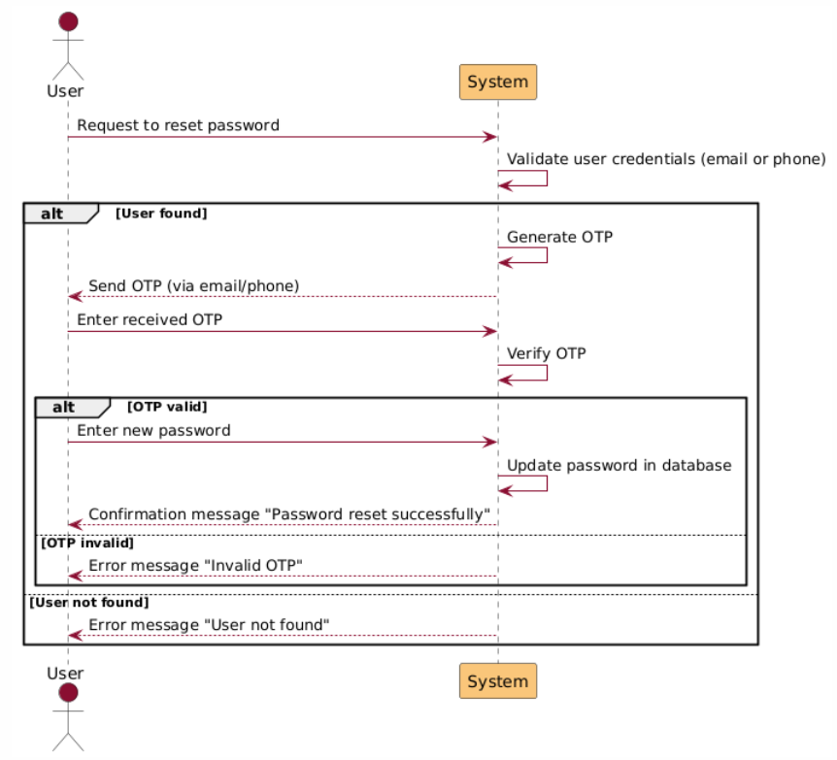

Figure Sequence Diagram 23 Forgot Password

G4: Student-Parent Access System

|  |  |
| --- | --- |
| Student And Parent Log-in | |
| Actors | Student, Parent |
| Description | This functionality allows students and parents to log in using their credentials (National ID/Phone Number and Password) to access their respective portals |
| Data | National ID/Phone Number, Password.. |
| Stimulus | Student or parent enters the data and make the Logn request |
| Response | On successful login: Redirect to the appropriate dashboard (Student or Parent).  On failure: Display an error message such as "The Username or Password is Wrong. |
| Scenarios | |  |  | | --- | --- | | 1. User navigates to the login page. | | |  | 2. User enters their National ID/Phone Number and Password. | |  | 3. User submits the form. | |  | 4. System verifies the credentials in the database. | |  | 5. On success, the system determines the user type and redirects them to their respective dashboard | |

Table Student And Parent Log-in Description

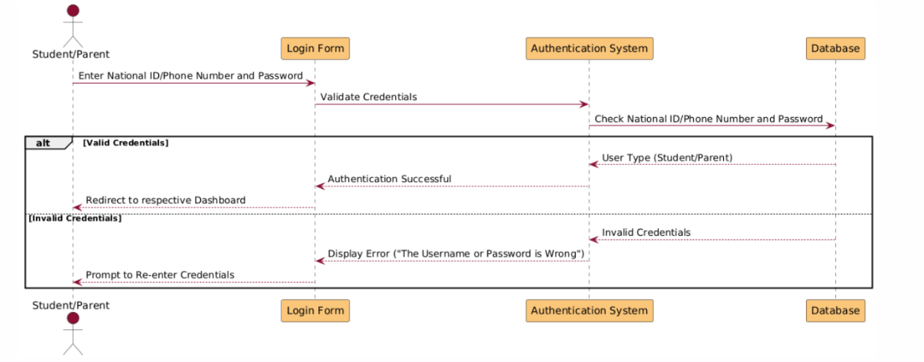

Figure Sequence Diagram 24 Student-Parent Log-in

|  |  |
| --- | --- |
| View Student Courses | |
| Actors | Parent, Student |
| Description | A Parent or Student can view a list of courses assigned to the student and select a course to see its details. |
| Data | 1. Student identifier.  2. List of courses.  3. Selected course details. |
| Stimulus | User requests to view the courses for a student. |
| Response | 1. Display the list of courses assigned to the student.  2. Display details of the selected course.  3. Error message if no courses are found. |
| Scenarios | **Normal Scenario**:  a. User requests to view courses.  b. System retrieves and displays courses.  c. User selects a course.  d. System retrieves and displays course details.  **Error Scenario**:  a. System finds no courses for the student.  b. System displays "No courses available." |
| Comments | Parents and Students can only view courses associated with the student. System ensures role-based access control. |

Table View Student Courses

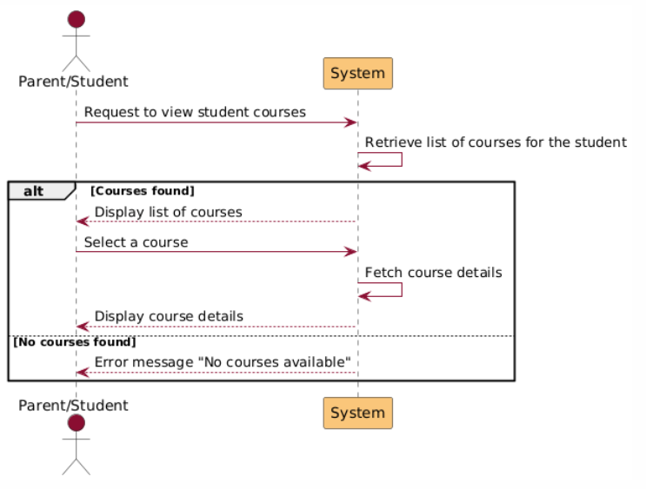

Figure Sequence Diagram 25 View Student Courses

|  |  |
| --- | --- |
| Upload File | |
| Actors | Student |
| Description | The student selects an assignment and uploads a file as part of their submission. |
| Data | 1. Assignment identifier.  2. File details (name, type, size). |
| Stimulus | Student uploads a file for a specific assignment. |
| Response | 1. File is saved to the database if valid.  2. Confirmation message is displayed.  3. Error message for invalid files. |
| Scenarios | **Normal Scenario**:  a. Student selects an assignment.  b. Student uploads a valid file.  c. System validates and saves the file.  d. Confirmation message is displayed.  **Error Scenario**:  a. Student uploads an invalid file (e.g., wrong type or size).  b. System displays "Invalid file type or size." |
| Comments | Files must meet predefined criteria for type (e.g., .pdf, .docx) and size. This ensures system compatibility and avoids misuse. |

Table Upload File

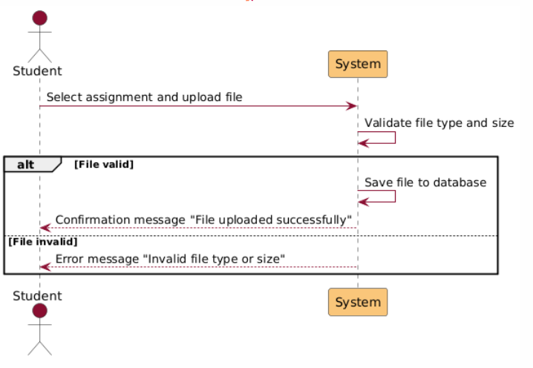

Figure Sequence Diagram 26 Upload File

|  |  |
| --- | --- |
| Delete File | |
| Actors | Student |
| Description | A student can delete a previously uploaded file from an assignment submission. |
| Data | 1. File identifier.  2. Assignment identifier. |
| Stimulus | Student requests to delete an uploaded file. |
| Response | 1. File is deleted from the database if it exists.  2. Confirmation message is displayed.  3. Error message if the file is not found. |
| Scenarios | **Normal Scenario**:  a. Student requests file deletion.  b. System verifies the file exists.  c. File is deleted from the database.  d. Confirmation message is displayed.  **Error Scenario**:  a. Student requests file deletion.  b. System cannot find the file.  c. Error message "File not found" is displayed. |
| Comments | Only files uploaded by the student can be deleted. This ensures the integrity of the submission system. |

Table Delete File Description

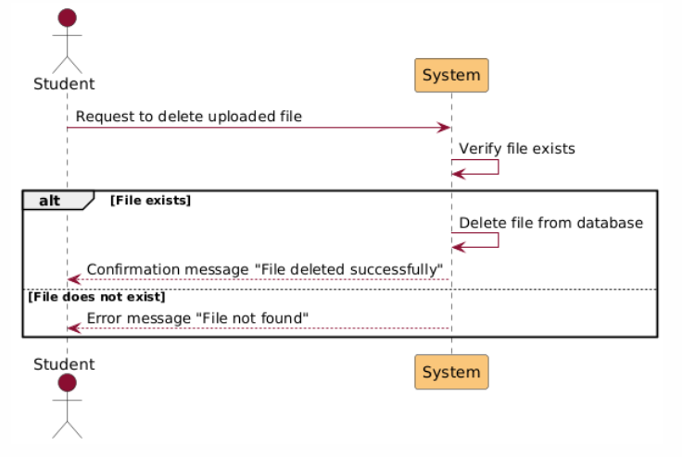

Figure Sequence Diagram 27 Delete File

|  |  |
| --- | --- |
| Download File | |
| Actors | Student |
| Description | This functionality allows students to download files (e.g., worksheets, assignments, or materials) provided by teachers. |
| Data | File selection by the student. |
| Stimulus | Student clicks the "Download" button for a specific file. |
| Response | On success: The file is downloaded to the student’s device.  On failure: Display an error message (e.g., "File not found" or "Network error occurred"). |
| Scenarios | **Normal Scenario**:   |  |  | | --- | --- | | 1. Student logs into the system and navigates to the course or activity page. | | |  | 2. Student identifies the desired file from the list of available resources. | |  | 3. Student clicks the "Download" button associated with the file. | |  | 4. The system retrieves the file from the server. | |  | 5. The file is downloaded to the student’s device. |   **Error Scenario**:  a. the student clicks on download button.  b. display an error message due to (“file not found” or “Network error occurred”) |
| Comments | Files must meet predefined criteria for type (e.g., .pdf, .docx) and size. This ensures system compatibility and avoids misuse. |

Table Download File Description

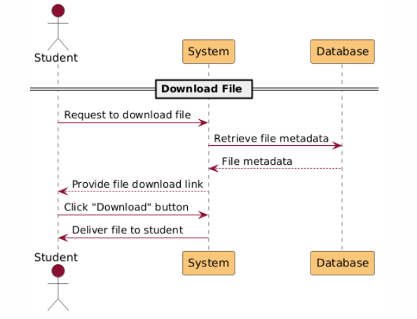

Figure Sequence Diagram 28 Download File

|  |  |
| --- | --- |
| View Grades | |
| Actors | Parent, Student |
| Description | A Parent or Student can view the grades for a specific course the student is enrolled in. |
| Data | 1. Course identifier.  2. Grades data (e.g., marks, total, grade breakdown). |
| Stimulus | User requests to view grades for a selected course. |
| Response | 1. System displays the grades if available.  2. Error message if grades are not available. |
| Scenarios | **Normal Scenario**:  a. User requests to view grades.  b. System retrieves and displays grades.  **Error Scenario**:  a. User requests to view grades.  b. System cannot find grades.  c. Error message "Grades not available" is displayed. |
| Comments | Parents and Students can only view grades associated with the student. This ensures privacy and accuracy. |

Table View Grades Description

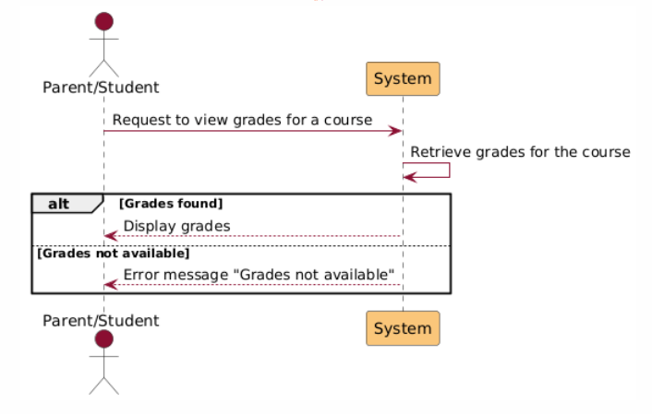

Figure Sequence Diagram 29 View Grades

|  |  |
| --- | --- |
| View Reports | |
| Actors | Parent |
| Description | A Parent can view performance and progress reports for their child in a specific course. |
| Data | 1. Student identifier.  2. Course identifier.  3. Report details (e.g., performance metrics, feedback). |
| Stimulus | Parent requests to view reports for a specific course. |
| Response | 1. System displays the reports if available.  2. Error message if no reports are found. |
| Scenarios | **Normal Scenario**:  a. Parent requests to view reports.  b. System retrieves and displays the reports.  **Error Scenario**:  a. Parent requests to view reports.  b. System finds no reports for the student.  c. Error message "No reports available" is displayed. |
| Comments | Only parents can view reports for their child. This ensures data privacy and relevance. |

Table View Reports Description

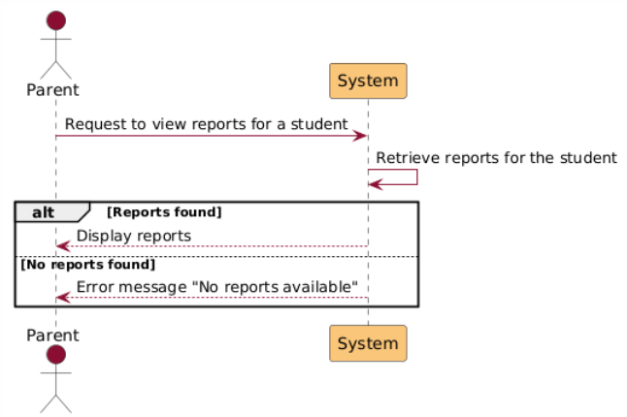

Figure Sequence Diagram 30 View Reports

|  |  |
| --- | --- |
| Show Absences | |
| Actors | Parent |
| Description | This functionality allows parents to view a list of their child’s absences from the start of the semester to the present date. |
| Data | Student ID (associated with the parent's account). |
| Stimulus | Parent selects the "Show Absences" option for a specific child |
| Response | On success: Display the absence data in a structured table format  On failure: Display an error message (e.g. "Error retrieving absences") |
| Scenarios | **Normal Scenario**:   |  |  | | --- | --- | | 1. Parent logs into the system. | | |  | 2. Parent navigates to their child’s profile or dashboard. | |  | 3. Parent clicks the "Show Absences" button. | |  | 4. System retrieves the child’s absence records from the database. | |  | 5. The absence records are displayed in a table format, including the date, class |   **Error Scenario**:  a. clicks o the absences button  b. System cannot find absences  c. Error message "absences not available" is displayed. |
| Comments |  |

Table Show Absences Description

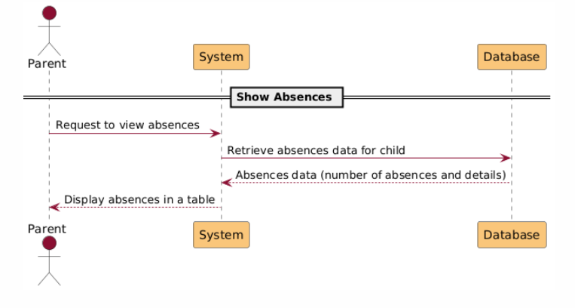

Figure Sequence Diagram 31 Show Absences

G5: Messaging System

|  |  |
| --- | --- |
| Search by name | |
| Actors | Student, Parent, Department manager, General manager, Secertary |
| Description | The messaging system allows users to search for other users by name. If the entered name does not exist in the system, an error message is displayed. If the user is found, the system checks whether the searching user is allowed to send messages to the target user based on specific rules. If allowed, the "Send Message" button becomes active. Otherwise, an error message appears.  **Messaging Permissions:**  **1-Students**  a-Can send messages only to:  b-Teachers in the same department.  c-Their Department Manager.  d-General Manager.  Secretary.  **2-Parents**  Can send messages only to:  Teachers in the same department as their child.  Department Manager.  General Manager.  Secretary.  **3-Department Managers**  Can send messages to: Secretary or General Manager.  Students and Parents in their department.  **4-General Manager and Secretary**  Can send messages to any user |
| Data | 1- Searched Name (input by the user).  2-User Role (searcher).  3-Messaging Permissions (rules). |
| Stimulus | A user enters a name in the search bar and clicks the search button. |
| Response | 1-If the name is not found, display:  “The User is not found.”  2-If the name is found, check permissions:  3-If the user is allowed to send messages:  Enable the "Send Message" button.  4-If the user is not allowed to send messages:  Display: “You can’t send message for this user.” |
| Scenarios | 1-Successful Search – Messaging Allowed:  a-The user searches for a name that exists in the system.  b-The system checks permissions and determines that messaging is allowed.  c-The "Send Message" button becomes active.  2-Successful Search – Messaging Not Allowed:  a-The user searches for a name that exists in the system.  b-The system checks permissions and determines that messaging is not allowed.  c-The system displays the error message: “You can’t send message for this user.”  3-Search for Nonexistent User:  a-The user searches for a name that does not exist in the system.  b-The system displays the error message: “The User is not found.”  4-Messaging Across Roles:  a-A student searches for a teacher in their department.  b-The system verifies the relationship and allows messaging.  c-A parent searches for a teacher outside their child’s department.  d-The system denies the action, displaying the appropriate error |
| Comments | Include suggestions for partial matches or similar names when a user is not found (“Did you mean: [similar name]?”). |

Table Search By Name

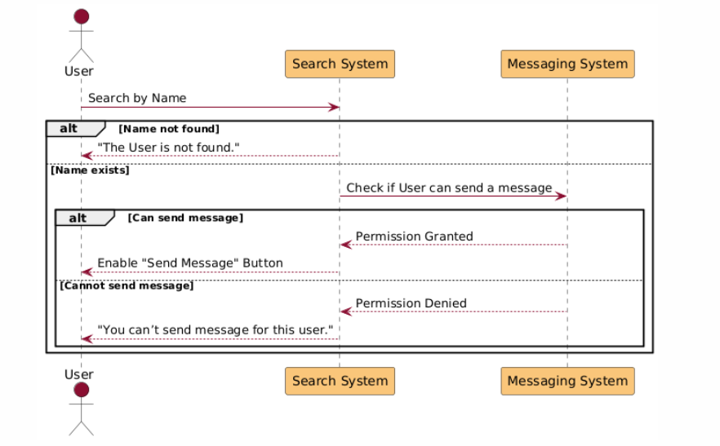

Figure Sequence Diagram 32 Search By Name

|  |  |
| --- | --- |
| Send message | |
| Actors | Students, Parents, Teachers, Department Managers, General Manager, Secretary |
| Description | This functionality allows users to send messages to authorized recipients. Each message includes essential details and, upon submission, is delivered to the receiver’s inbox. Messages are timestamped for tracking purposes.  Message Components:  Sender – The user who sends the message.  Receiver – The user who receives the message.  Message Content – The text of the message, provided by the sender.  Message Timestamp:  Date: Year/Month/Day.  Time: Hour: Minute. |
| Data | 1-Sender ID  2-Receiver ID  3-Message Text  4-Timestamp (generated automatically upon submission) |
| Stimulus | The user enters the message content, selects the recipient, and clicks the "Send Message" button. |
| Response | 1-If the sender is authorized to message the recipient:  The message is saved in the database with the provided details.  The message appears in the recipient’s inbox.  A success notification is displayed (“Message sent successfully!”).  2-If the sender is not authorized:  The system displays an error message (“You are not allowed to send a message to this user.”). |
| Scenarios | 1-Successful Message Delivery:  a-The user selects a valid recipient and composes a message.  b-Upon clicking "Send Message," the system validates the relationship between the sender and receiver.  c-The message is timestamped, stored in the database, and delivered to the recipient’s inbox.  d-The sender sees a success notification.    2-Failed Message Delivery – Unauthorized Access:  a-The user attempts to send a message to a recipient they are not authorized to contact.  b-The system blocks the action and displays the error message: “You are not allowed to send a message to this user.”  3-Failed Message Delivery – Missing Content:  a-The user clicks "Send Message" without entering message content.  b-The system prompts the user to fill in the message text (“Message content cannot be empty.”).    4-Failed Message Delivery – Recipient Not Selected:  a-The user clicks "Send Message" without selecting a recipient.  b-The system prompts the user to select a recipient (“Please select a recipient to send the message.”). |
| Comments | 1-Ensure the timestamp is generated on the server to prevent manipulation by the client.  2-Allow users to view the delivery status ("Sent," "Delivered"). |

Table Send Message Description

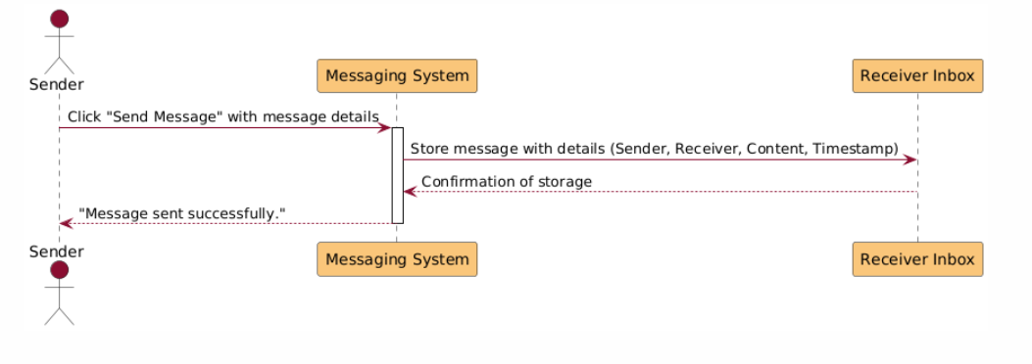

Figure Sequence Diagram 33 Send Message

|  |  |
| --- | --- |
| Receive message | |
| Actors | Students, Parents, Teachers, Department Managers, General Manager, Secretary |
| Description | When a message is successfully sent, the recipient's inbox updates to display a notification. Notifications count conversations with new messages as a single notification, regardless of the number of new messages within that conversation. Users can view their inbox to see all active conversations.  Inbox Functionality:   1. Notification Badge:    1. Displays the number of conversations with new messages.    2. Each conversation with new messages is counted as 1, regardless of the number of unread messages within the conversation. 2. Inbox Section:    1. Shows all conversations, including their latest messages.    2. Conversations with new messages are highlighted or marked (e.g., bold font or an "unread" indicator). 3. Message Details in Conversation View:    1. Sender.    2. Message content (text).    3. Timestamp (Date and Time). |
| Data | 1-Recipient ID  2-Message Details (Sender, Content, Timestamp)  3-Conversation ID |
| Stimulus | A message is sent to the recipient and successfully delivered to their inbox. |
| Response | 1-The recipient's inbox updates to reflect a new notification.  2-The conversation containing the new message appears at the top of the inbox.  3-The recipient can open the conversation to view the message. |
| Scenarios | 1-Successful Message Notification:  a-The recipient receives a new message.  b-The inbox displays an updated notification count (“3” for three conversations with new messages).  c-The conversation with the new message appears at the top of the inbox.  2-Viewing a Conversation:  a-The recipient opens the inbox and selects a conversation.  b-The system marks the conversation as “read” and updates the notification count.  c-All messages in the conversation are displayed in chronological order, with the latest at the bottom  3-No New Messages:  a-The recipient opens their inbox, which displays all conversations with no new message notifications.  4-Conversation Highlight for New Messages:  a-A conversation with unread messages is visually distinct (bold text or a colored badge).  b-Once opened, the visual indicator is removed. |
| Comments | 1-Include options to archive or delete conversations.  2- Provide message delivery status to senders (“Delivered” or “Read”) |

Table Receive Message Description

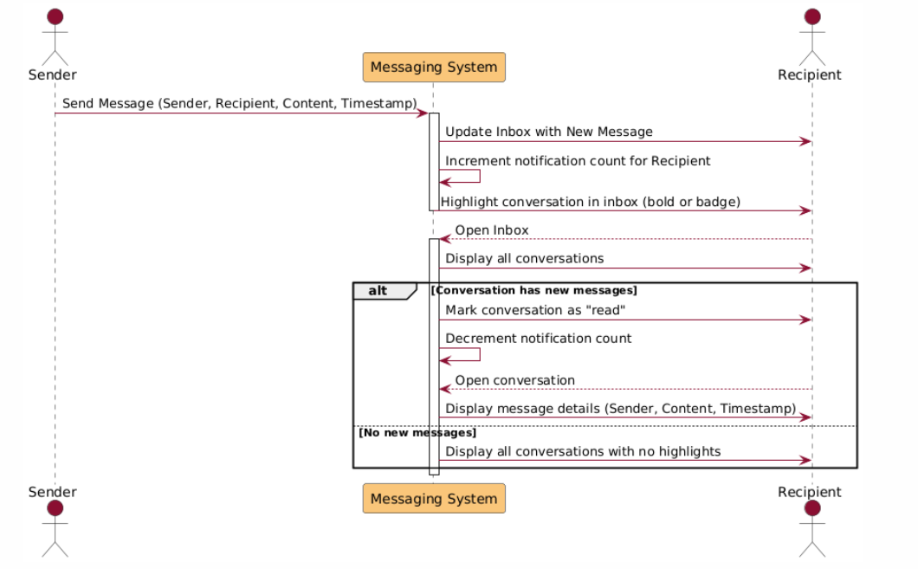

Figure Sequence Diagram 34 Receive Message

|  |  |
| --- | --- |
| Send Announcement | |
| Actors | General Manager, Department Manager |
| Description | The General Manager can send announcements to a specific group of users or all users. The targeted group can be selected using checkboxes for user roles and sections. If "All" users are selected, other role-based checkboxes are disabled. Additionally, the General Manager can select up to three sections to further refine the audience.  Department Managers can send announcements to specific user roles, but their section is pre-selected and cannot be changed.  Targeted User Selection:  1-User Role Checkboxes:  All (selects all users and disables other role checkboxes).  Teachers.  Parents.  Students.  2-Section Checkboxes (General Manager Only):  KG.  Primary.  Intermediate Males.  Intermediate Females.  The General Manager can select up to 3 sections at a time.  3-Section Checkboxes (Department Manager):  Pre-checked to match the manager’s department (cannot be changed). |
| Data | 1-Announcement Content (text).  2-Targeted User Roles.  3-Targeted Sections.  4-Timestamp of the announcement |
| Stimulus | The user (General Manager or Department Manager) selects the desired roles and sections, composes the announcement, and clicks "Send Announcement." |
| Response | 1-The announcement is delivered to the selected users and sections.  2-A success message is displayed ("Announcement sent successfully!"). |
| Scenarios | 1-General Manager Sending to All Users:  a-The General Manager selects "All" in the user role checkboxes.  b-The section checkboxes are automatically disabled.  c-The announcement is sent to all users across all sections.  2-General Manager Sending to Specific Users and Sections:  a-The General Manager selects specific roles ("Teachers" and "Students").  b-The Manager selects up to three sections ("KG," "Primary," and "Intermediate Males").  c-The announcement is sent only to the chosen roles within the selected sections.  3-Department Manager Sending to Specific Roles in Their Section:  a-The Department Manager selects specific roles ("Parents" and "Students").  b-The section checkbox is pre-checked and unmediatable ("Primary").  c-The announcement is sent to the chosen roles in the manager's section.  4-Failed Announcement – Exceeding Section Limit (General Manager Only):  a-The General Manager selects more than three sections.  b-The system prevents the action and displays an error message (“You can select up to 3 sections only.”).  5-Failed Announcement – Missing Content:  a-The user attempts to send an announcement without entering content.  b-The system prompts the user to provide content (“Announcement content cannot be empty.”). |
| Comments | 1-Include a preview feature to allow users to review announcements before sending them.  2-Add a confirmation dialog for final approval (“Are you sure you want to send this announcement?”). |

Table Send Announcement Description

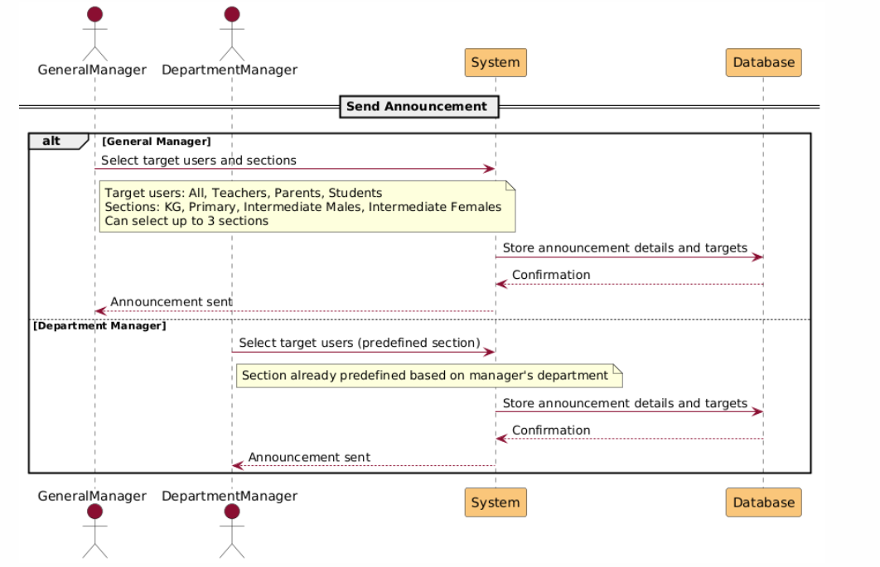

Figure Sequence Diagram 35 send Announcement

G6: Posts System

|  |  |
| --- | --- |
| **Add Post** | |
| Actors | General Manager, Department Manager |
| Description | Managers can add posts in the posts section. A post must include multimedia (images, videos) with or without a description. The filter in the posts page gives priority to the newest posts. |
| Data | 1. Date (Year/Month/Day).  2. Time (Hour:Minute).  3. Description.  4. Multimedia (Images/Videos). |
| Stimulus | Manager submits a request to create a new post. |
| Response | 1. The post is saved to the database.  2. Post is displayed in the posts section, sorted by date and time. |
| Scenarios | **Normal Scenario**:  a. Manager submits post details.  b. System validates the input.  c. Post is saved to the database.  d. Post appears in the posts section.  **Error Scenario**:  a. Manager submits invalid post details.  b. System rejects the request with an error message. |
| Comments | Posts with missing or invalid multimedia or descriptions are not accepted. Filtering ensures newest posts appear first. |

Table Add Post Description

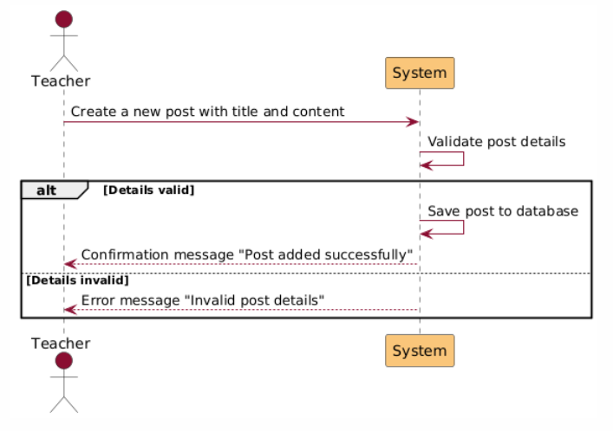

Figure Sequence Diagram 36 Add Post

|  |  |
| --- | --- |
| **Delete Post** | |
| Actors | Department Manager, General Manager |
| Description | This functionality allows managers to delete a specific post from the system, ensuring the post is no longer visible to users. |
| Data | 1. Post identifier.  2. Post details (e.g., description, multimedia). |
| Stimulus | Manager submits a request to delete a specific post. |
| Response | 1. The post is removed from the database.  2. Confirmation message is displayed.  3. Error message if the post does not exist. |
| Scenarios | **Normal Scenario**:  a. Manager requests to delete a post.  b. System verifies the post exists.  c. System removes the post and confirms deletion.  **Error Scenario**:  a. Manager requests to delete a post.  b. System determines the post does not exist.  c. Error message is displayed. |
| Comments | Posts can only be deleted by authorized managers. System validation prevents accidental deletions. |

Table Delete Post Description

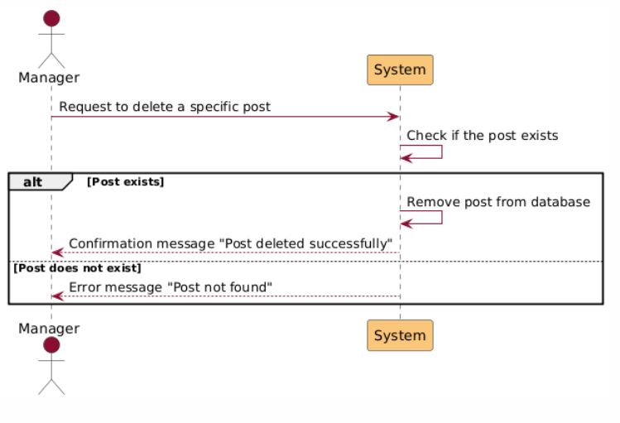

Figure Sequence Diagram 37 Delete Post

|  |  |
| --- | --- |
| **Edit Post** | |
| Actors | Department Manager, General Manager |
| Description | Managers can edit specific posts. They can update the description, add multimedia, or remove multimedia. |
| Data | 1. Post identifier.  2. Updated post details (e.g., description, multimedia). |
| Stimulus | Manager submits updated details for an existing post. |
| Response | 1. Post is updated in the database.  2. Confirmation message is displayed.  3. Error message if the details are invalid. |
| Scenarios | **Normal Scenario**:  a. Manager submits updated post details.  b. System validates the updates.  c. System updates the post and confirms the changes.  **Error Scenario**:  a. Manager submits invalid or incomplete details.  b. System rejects the updates and displays an error message. |
| Comments | System ensures posts meet validation criteria before updates are saved. Only authorized managers can edit posts. |

Table Edit Post Description

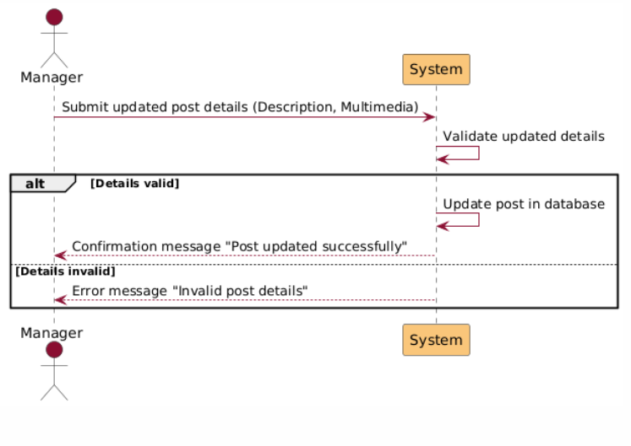

Figure Sequence Diagram 38 Edit Post

## 4.5 Database Design

**EERD:**

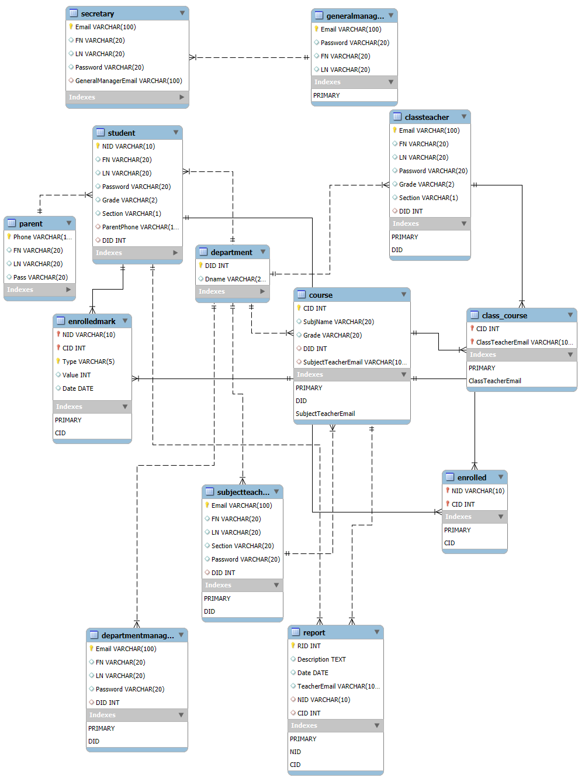

Figure EERD

**JSON General Formats:**

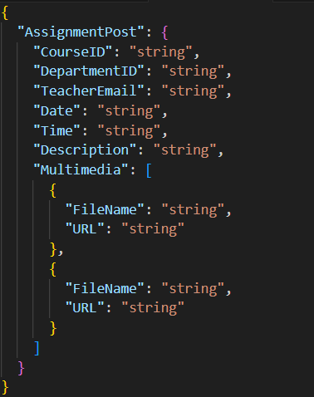

Figure JSON Format 1 Assignment Post

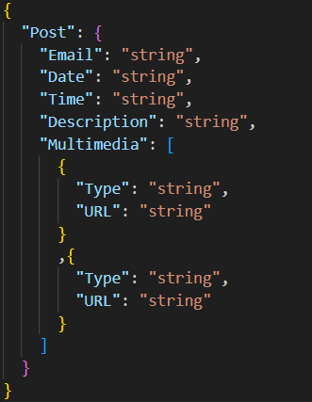

Figure JSON Format 2 Post

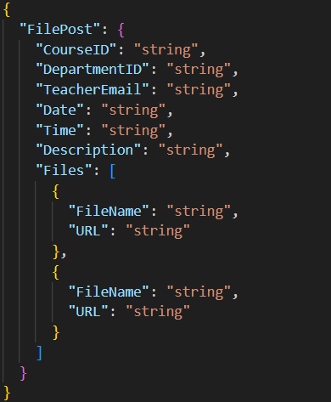

Figure JSON Format 3 FilePost

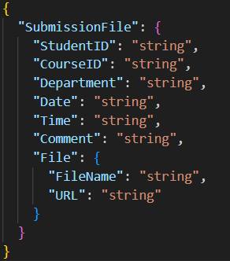

Figure JSON Format 4 SubmissionFile

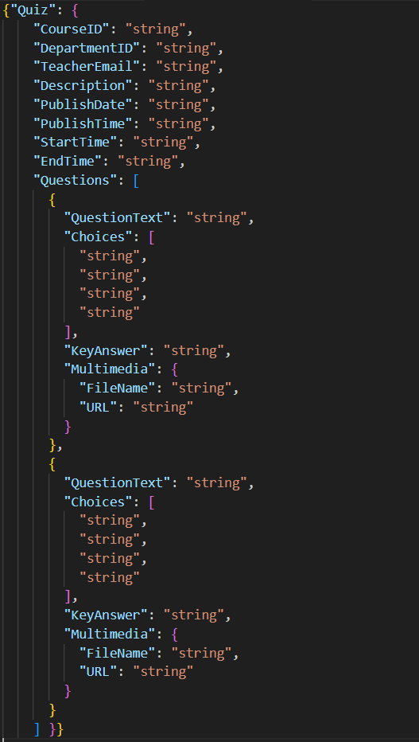

Figure JSON Format 5 Quiz

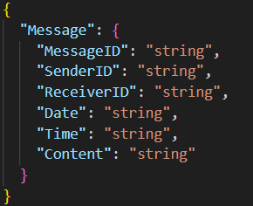

Figure JSON Format 6 Message

Figure JSON Format 7 Lecture Post

Have A Great Time 😊  
ILM Verse TEAM